SULEYMAN DEMIREL UNIVERSITY
FACULTY OF ENGINEERING AND NATURAL SCIENCES


DIGITAL DESIGN

LABORATORY WORKS
DESCRIPTIONS AND TEST EXAMPLES

Authors: Dr. M. Ertugrul, Dr. L. Kiziyeva, Dr. Zafer Karacan, MSc. R. Suliyev

Almaty

2014

УДК ____________
ББК ____________
____

Утверждено и рекомендовано Ученым Советом Университета имени Сулеймана Демиреля, протокол № ___ от _______________

Авторы: Кизиева Лариса Александровна
Эртугрул Меликшах
Зафер Караджан
Сулиев Расим

К Кизиева Л.А., Эртугрул М., Сулиев Р., Караджан З. Проектирование цифровых систем. Лабораторные работы (Описания и образцы тестовых заданий). Алматы, 2014-___с.

ISBN _______________

ISBN ____________  Кизиева Л.А., Эртугрул М. Сулиев Р., Караджан З.
 Университет имени Сулеймана Демиреля, 2014

PREFACE
  - 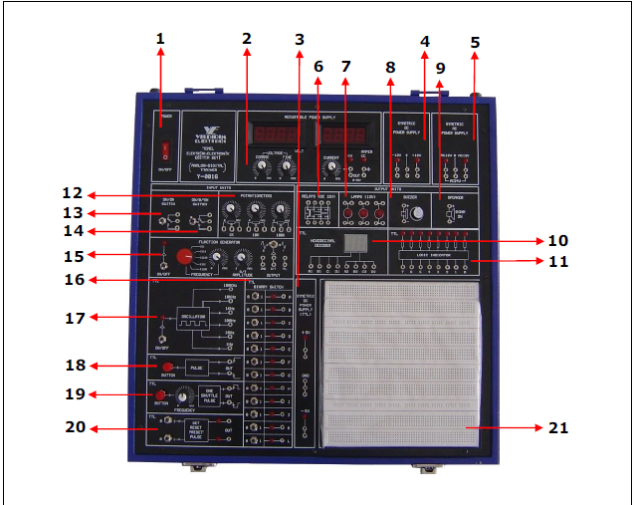
1. Power ON/OFF
2. 0-36V, 0-1A Current protected, adjustable power supply
3. (-5V)-0(+5V) Electronically protected, symmetric DC power supply
4. (-12V)-0(+12V) Electronically protected symmetric DC power supply
5. 12V-0-12V AC supply
6. Relay (DC 12V)
7. 3xLamp (12V)
8. Buzzer
9. 8 Ohm – 2 W Speaker
10. Hexadecimal Decoder
11. 8 bit Logic Indicator
12. Potentiometers (1k-10k-100k)
13. Switch (on-on)
14. Switch (on-0-on)
15. 1 Hz-100 KHz Function Generator (SINE, TRIANGLE, TTL )
16. 12 bit TTL Binary Switch
17. 1Hz–10Hz-100Hz-1KHz-10KHz- 100KHz Oscillator
18. TTL Pulse
19. One Shuttle TTL Pulse
20. Set, Reset, Preset Pulse
21. Protoboard

USAGE OF THE CIRCUITS IN BASIC ELECTRICS – ELECTRONICS EDUCATION SET

1- POWER (ON-OFF)
It is used to give energy to the training set and the experiment circuitry.

2- ADJUSTABLE DC POWER SUPPLY
When the power switch position is “ON”, energy is given to 0-36V, 0-1A adjustable power supply. When the energy is given to the power supply, current and voltage potentiometer displays will illuminate. You can adjust the current using CURRENT potentiometer, and voltage using VOLTAGE potentiometer. Make sure that the CURRENT potentiometer is rotated to the leftmost position. So that there will be no voltage at the circuit and CC LED will be illuminating. At normal operating condition, CV LED will be illuminating. In order to obtain a desired current, first make the output nodes short circuited by rotating the CURRENT potentiometer to the leftmost position. Then rotate the potentiometer to the right up to the desired current value. The voltage is adjusted roughly by using COARSE potentiometer first, then the accurate adjustment is done by using FINE potentiometer.

3-(-5V) 0 (+5V) SYMMETRIC DC SUPPLY
When the output is shorted, the supply protects itself and the related LED in the TTL power on-off block becomes off. In order to operate the system again turn off the power on-off switch, wait for 5 seconds and turn on the switch.
NOTE: The ground pin is independent. Be careful about this when connecting the circuit.

4- (-12V) 0 (+12V) SYMMETRIC DC SUPPLY
When the output is shorted, the supply protects itself and the LED in the output socket becomes off. In order to operate the system again turn off the power on-off switch, wait for 5 seconds and turn on the switch.
NOTE: The ground pin is independent. Be careful about this when connecting the circuit.

5- 12V-0-12V SYMMETRIC AC SUPPLY
When the output is shorted, the supply protects itself and the LED in the output socket becomes off. In order to operate the system again turn off the power on-off switch, wait for 5 seconds and turn on the switch.
NOTE: The ground pin is independent. Be careful about this when connecting the circuit.

6- RELAY
A DC 12V double group contactor relay

7- LAMPS
3 incandescent lamp (12 V)

8- BUZZER
The element that produces sound with constant frequency when voltage is applied on the input terminals

9- SPEAKER
It includes an 8 Ohm - 2 Watt speaker in order to be used in analog experiments. It is connected by using the input terminals.

10- HEXADECIMAL DECODER
It is the circuitry that converts BINARY coded data to HEXADECIMAL form. It converts the BINARY data in the form of 0’s and 1’s at the input into HEXADECIMAL codes between 0 and F.

11- 8 BIT LOGIC INDICATOR
It is used for the data in the form of 0-1 to be indicated by LEDs. If the data is “0”, LED does not illuminate and if the data is “1”, LED illuminates.

12- POTENTIOMETERS
3 Potentiometers (1K, 10K and 100K)

13- SWITCH (ON-ON)
A (on-on) switch

14- SWITCH (ON-0-ON)
A (on-0-on) switch

15- FUNCTION GENERATOR
A function generator that can produce sinusoidal, triangular and square waves with frequencies between 1HZ to 100 KHz and with adjustable amplitudes.
NOTE: The ground pin is independent. Be careful about this when connecting the circuit.

16- 12 BIT TTL BINARY SWITCH
It is used to obtain logic levels “0” and “1”. 12 switches are used for 12 bit data. LEDs are used in order to show the switch position and output data.

17- CONSTANT FREQUENCY SELECTIVE TTL OSCILLATOR
It is the oscillator circuit that produces 1Hz-10 KHz-100Hz-1 kHz-10 KHz-100 KHz signals in the TTL level. Desired frequency can be obtained from the output terminals.

18- TTL PULSE CIRCUIT
It is used to obtain logic pulse. When the button is pressed, both negative and positive pulses are generated. The desired pulse can be taken from the related output terminal.

19- ONE SHUTTLE TTL PULSE CIRCUIT
It is the circuit that can produce positive and negative pulses with adjustable frequency. Whenever the button is pressed, a pulse is generated at the adjusted frequency.

20- TTL SET-RESET-PRESET PULSE CIRCUIT
It is a general purpose PULSE generator of which output is determined according to the position of its input switch.

21- PROTOBOARD (BREADBOARD)
It is the component on which the circuits can be set up and external experiments can be done. The information about usage is given in the figure below.
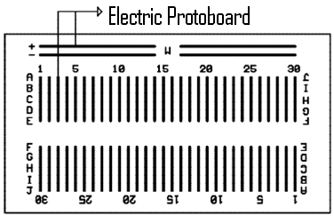
Standard experiments are done by replacing the Protoboard with Y-0016/001-014 modules.
Preliminaries 1
RESISTORS’ COLORED CODES.
4 band resistor
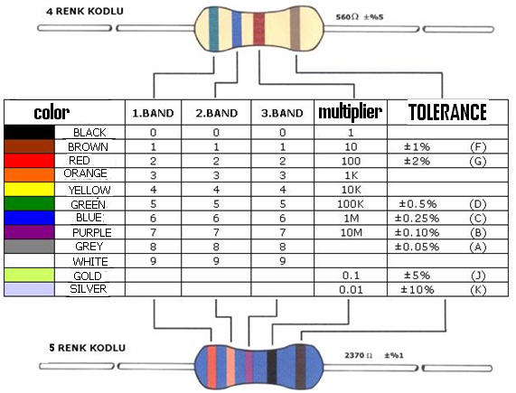
5 band resistor
Figure 1.12
As we see, the last color shows the tolerance. Tolerance determines the maximum and minimum values of resistance. Carbon resistors have higher tolerances than metal film resistors. Because of that, metal film resistors are used in precision-bored (delicate) circuits while carbon resistors are used in circuits which are not precision-bored. For instance, let’s calculate the value of resistance and limits of resistance values according to the tolerance of a four band resistor on which there are colors of brown, black, red and gold.

1.Colour  (1.Number) | 2.Colour  (2.Number) | 3.Colour  (Multiplier) | Value  (Ohm) | Tolerance  (%)
1 | 0 | 00 | 1000R | 5

% ±5 tolerance = 1000*(5/100) = 50R
This means that the resistance is between 1000-50= 950 R and 1000+50=1050 R.

For instance, let’s calculate the value of resistance and limits of resistance values according to the tolerance of a five band resistor on which there are colors of red, red, black, brown and purple.

1.Colour  (1.Number) | 2. Color  (2.Number) | 3. Color  (3.Number) | 4. Color  (Multiplier) | Value  (Ohm) | Tolerance  (%)
2 | 2 | 0 | 0 | 2200R | 0.1

% ±0,1 tolerance = 2200*(0.1/100) = 2.2R
This means that, the resistance value is between 2200-2.2=2197,8R and 2200+2.2=2202.2
Smaller the tolerance limits of a resistor, better is the resistor.
In delicate electronic circuits, tolerances of some resistors are specifically shown on a schema. If these kinds of circuits are being applied, attention must be paid to the tolerance value. Another point to pay attention is the power of resistor. Power of resistors is determined as Watt (W). If too great currents pass through the resistors and if the resistors do not have enough power they may be heatened and deformed. Because of that, you should use the resistors which have enough power suitable for the structure of the circuit. Resistors present the same opposition to the direct current (DC) and alternating current (AC). This opposition is called “ohmic resistance”.

Preliminaries 2
MEASUREMENTS with DIGITAL MULTIMETER.

Digital multimeter is a multifunctional instrument. It can measure resistance, capacitance, DC and AC voltage, DC and AC current, short-circuit. It can help us to define transistor’s base, emitter and collector, anode and cathode for diode.
Process of measurement.
Before the work it needs to check if the instrument ready to work. For this purpose in the mode “measurement of resistance” it needs to connect test leads (range of measurement is 200 Ω). The sound signal will appear to inform us about short-circuit. It means that the instrument is suitable for measurement. This mode is used for searching short-circuit somewhere in the electric circuit. In other positions of the pointer (not “measurement of resistance”) we can see 0 on the display without contact between the leads.

- Measurement of resistance.
Resistances are measured by “Ohmmeter”. The resistance that ohmmeters measure is ohmic resistance. Ohmmeters are devices that contain a DC (direct current) in themselves. A small current passes through the resistor during the measurement; ohmmeter examines this current and makes the measurement. The direction of this current does not affect the measurement. Ohmmeters are produced in two types: analog and digital (or numerical) types. It is difficult to measure delicate values with analog ohmmeters because their quadrants are not linear and they need selection of applicable level and caliber adjustment. There is also room for delusions of eye while reading the values. So, their production is very limited. Digital devices are commonly used by electricians. They can measure electric current (Amper), electric voltage (volt) and resistance (ohm). These devices are also called “MULTIMETER” (Amper-Volt-Ohm). Delicate values can be read by digital multimeters and they are easy to use. A typical multimeter can be seen in figure 1.13
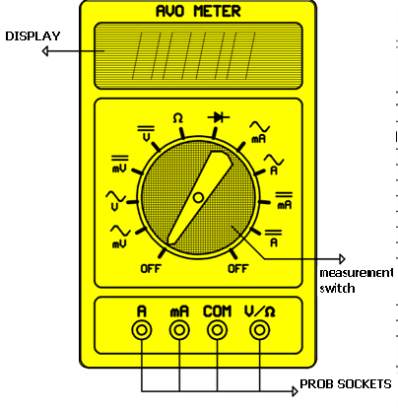
Figure 1.13
The cables that are used to connect the terminals of the measured component to the multimeter are called “probes”. Probes have special plugs on both sides. The part of the probe that we grab by the hand is made of good insulators and the parts (terminals) that are used for measurement are made of good conductors. The conducting parts are also called “live terminals”. In order to prevent problems of usage, probes are produced as black and red. Black probe is called (-) negative probe and red probe is called (+) positive probe. Resistance measurement with multimeter is shown in figure 1.14
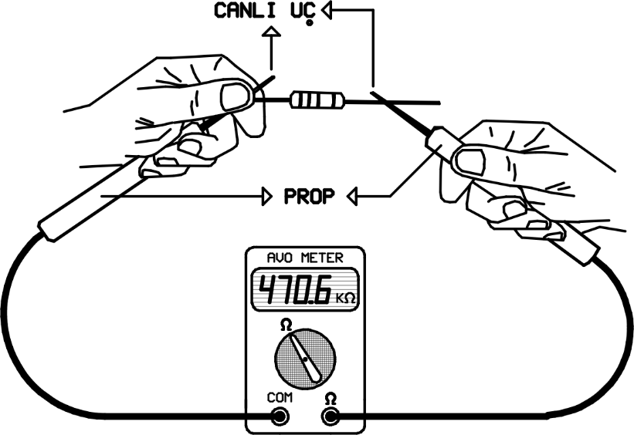
Figure 1.14 (prop: probe, canlı uç: active terminals)
Black probe will be plugged to “com” socket in all measurements. Red probe will be plugged to the socket of related measurement unit. In resistance measurement, the red probe will be plugged to ohm socket. The switch will be adjusted to “ohm.
If the resistance is connected to a circuit, it should be disconnected from the circuit before measurement. Otherwise, supply of the circuit will damage the ohmmeter. If there is not a supply connected to the circuit, even so, the resistance should be disconnected from the circuit because the other components cause miss-measurement. The second point to pay attention is that if the measured resistance has a big value, you should not touch the terminals of the probe. Otherwise, resistance of your body will also be measured and the result will be wrong.

- Measurement of DC voltage.
Set the FUNCTION switch to the position “measurement of DC voltage” and connect the test leads across the source or load under measurement. Connect the BLACK test lead to the COM jack and the RED test lead to the V/Ω jack. After checking define range of measurement. Range for DCV-200mV-1000V. For DCV: if polarity is wrong, indications will be with sigh “-“. About correctness of measurement range we can judge comparing measuring parameter and chosen range. If measuring parameter is over the lower measuring range, you should switch the FUNCTION switch to it to increase measurement accuracy. If measuring parameter is out of the range there is 1 on the display. In case of measurement of the same value in different ranges the accuracy of measurement will be different. For example, if V=1.5V: range 2V- the result is 1.505 V( three digits after decimal point); range 20V-the result is 1.51V( two digits after decimal point); range 200V-01.5V (one digit after decimal point). To increase accuracy it needs to choose the range, which corresponds to measuring parameter.

- Definition of p-n-junction resistance.
In spite of the fact that it is resistance, we can’t use position of the FUNCTION switch “measurement of resistance”. We will see 1 on the display in this case. We must use for the switch a special position, where convention of the diode is situated. Test leads are in the position for voltage measurement. We touch pins of the diode by test leads. If we have reverse bias, we can see 1 on the display. If it is forward bias, we can see some definite value on the display. It is the diode’s resistance and it is definition of the diode’s anode and cathode. RED test lead in this case is connected with anode. If the diode is LED one, it can light.

DEFINITIONS

Electricity: It is a type of energy. Electrical energy is generated by two different points having different number of electrons in any condition. The number of electrons that a point has is called the electrical charge or the electrical potential of that point. The thunderbolt which comes into being between the earth and the clouds can be given as an example to electrical energy.
Coulomb: the unit showing the number of electrons. 1 coulomb=625.10¹⁶ electrons
Electric current: it is the flow of electron between two different points. “Amper” is its unit. Amper is the speed of the flow of 1 coulomb electrons in 1 second between any two different points. The point that has more electrons is electrically negative. The point to where the electrons move is positive. Those points are called “poles”. So, the electron flow is from negative to positive. Electric current is just the flow of electrons. The direction of the electric current is assumed as from positive to negative (opposite to the direction of electron flow) in order to avoid showing negative sign in mathematical operation. Measurement devices of electrics and electronics are produced in compliance with the direction of circuit.
Direct current: The current of which the direction does not change. Direct current is symbolized by “DC”. Some DC types are shown in figure 2.
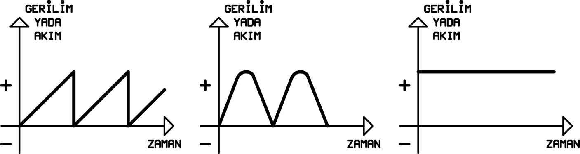
Figure 2 (gerilim yada akım: voltage or current, zaman: time)
The change in the magnitude of voltage or current in the direct current supply does not affect the working of some electrical devices. However, direct current is required to be constant in electronical devices. The supplies in the direct current circuits are used as voltage supply, adjustable voltage supply, current supply or adjustable current supply. Output voltage of the adjustable voltage supply and the current that is given by the adjustable current supply can be adjusted. DC supply symbols are shown in figure 3.
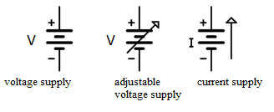
Figure 3
The units which the electric energy makes work is called load. In figure 4, a load is connected to the terminals of a DC supply. During the work time, the direction of the current passing through the load does not change.
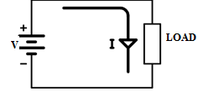
Figure 4
Also, the magnitude of DC does not change in the supplies that we use in daily life. DC is generally generated by using chemical ways. For example, batteries or accumulators.
Alternating Current (AC): Electrical current which periodically reverses direction and magnitude. It is symbolized by “AC” (Alternating Current). Pendulum swing is an example of periodical move. Pendulum swing is from the midpoint and at equal distance to both sides. Half of the pendulum move is called “Alternation”. A complete move of the pendulum consisting of two alternations is called a “period.” A period is shown in figure 5.
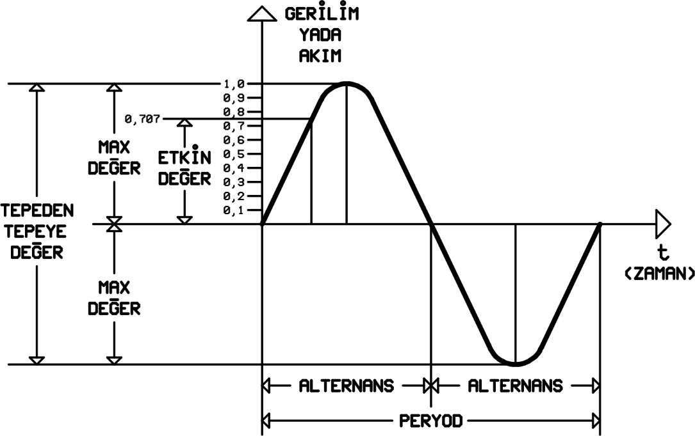
Figure 5
City network, generators are the sources of alternating current. Magnitude of the alternating current also varies during the work time. The magnitude of AC at any moment is called “instantaneousvalue.” Instantaneous value is shown by “e” for voltage and by “i” for current. Measurement devices measure the effectivevalue of the AC. Effective value is also called RMS (Root-Mean-Square). Effective value is the one we use in daily life. Effective value is shown by “E” for voltage and by “I” for current. The maximum value of an alternation is called “maximum value.” Maximum value appears twice in a period: one in negative alternation and one in positive alternation. Maximum value is shown by “Emax” for voltage and by “Imax” for current. In the experiments of this book, mostly, the oscilloscope will be used. Oscilloscopes are the devices by which we can see and measure the electrical wave forms. “Peak to peak value” is the AC value which is the easiest one to measure by oscilloscope. Peak to peak value is the sum of two maximum values in a period. It is shown by “Epp” for voltage and by “Ipp” for current. “pp” means peak to peak. Commonly used values for AC is shown in figure 5.
The number of period in a second is called “frequency.” Its unit is Hertz (Hz). Commonly used values of frequency are the Kilohertz (KHz) and Megahertz (MHz). Mathematical relations of these units are shown in figure 6.
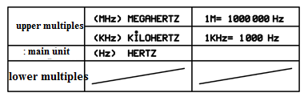
Figure 6
AC supplies are used as voltage and current sources. Ac supply symbols are shown in figure
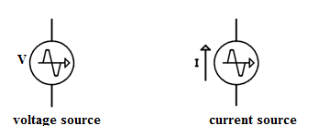
Figure 7
In figure 8, a load is connected to the terminals of an AC supply. The direction of the current passing through the load varies during the work time depending on the change of the supply poles.
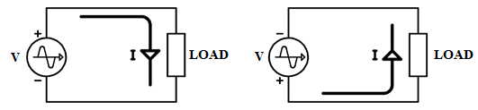
Figure 8
AC is the electrical energy which is used in domestic electrical and electronical devices, industry and almost in every aspect of life. AC can be converted to DC by basic methods. Supply is also called “generator.”
Electric Voltage: Voltage is a representation of the electric potential energy per unit charge. It is shown by “V” and its unit is “Volt”.
Conductor: The materials that allow electric current to pass through. Gold, silver and copper are good conductors.
Non-Conductor: The materials that does not allow electric current to pass through. Air, plastic and mica are non-conductors.
Semiconductor: A semiconductor is a solid whose electrical conductivity can be controlled over a wide range, either permanently or dynamically. Semiconductors are tremendously important.
Passive Components: Component of a circuit should be learned well in order to accommodate electrical circuits. Circuit arrangements and fault determination processes will be eased if the structures and properties of components are learned well. The component which doesn’t do amplification is called “passive circuit components”. Commonly used passive components are resistors, inductors and capacitors.

LABORATORY WORK # 1
DIODE and TRANSISTOR APPLICATIONS

Aims: investigate properties of diodes, LEDs, and transistors. Define what logic gates are realized schematically, learn the gates’ properties. Improve skills of the scheme mounting. Compare experimental results with theoretical foundations about diodes.

PREPARATION TO LAB WORK
- Learn the information about diodes, LEDs, and transistors.
- Show semiconductor diode i-v-characteristic.
- Show bipolar transistor’s characteristics.
- Consider experiments’ schemes and draw them with application of Scheme Design System. Analyze what gates are realized on the schemes’ basis. Fill in the tables theoretically.
- Answer the questions below in written form.
  - What is a semiconductor diode?
  - What is diode’s forward/reverse bias?
  - What is diode’s cathode/anode?
  - How can you define cathode and anode for real diode?
  - Explain a semiconductor diode’s behavior according to its i-v-characteristic.
  - What is LED?
  - What is a bipolar transistor?
  - What are names of a bipolar transistor’s electrodes?
  - How to define situation of a bipolar transistor’s electrodes?
  - What are conditions to have a bipolar transistor ON(OFF)?
  - What types of bipolar transistors do you know?
  - What are typical silicon transistor’s parameters?
  - What modes of a bipolar transistor’s operation do you know?

LAB WORK PERFORMANCE
- Demonstrate presence of your home preparation for lab work to your instructor.
- Pass test of 10 questions.
- Get a permission to begin the work.
- Mount the schemes of experiment 1A on the breadboard and perform them.
- Make a conclusion about functionality of the schemes. Compare your results with theoretical ones.
- Demonstrate your results to your instructor. If your results are correct you may dismount your scheme, if no – find the mistake.
- Repeat steps 4 to 6 for experiment 1B, 1C.
- Be ready to answer your instructor’s questions in process of work.
- Complete your work, dismount your schemes, and clean your working place.
- Answer your instructor’s final questions, obtain your mark.
- Ask your instructor’s permission to leave.
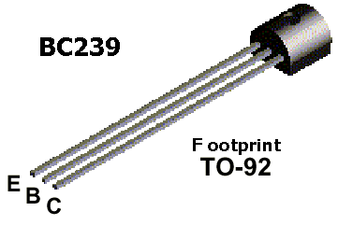
Experiment 1A. Realize the following circuit on a breadboard. Connecting A, and B inputs to either GND or VCC based on the following table, fill in the blanks. Write ON or OFF for LEDs. Measure Vout voltage.

 | INPUT | OUTPUT |  |  |  | INPUT | OUTPUT
 | A | LED 0 (ON/OFF) | Vout (V) |  |  | A | LED 0 (ON/OFF) | Vout (V)
1 | 5V |  |  |  | 1 | 5V
2 | 0V |  |  |  | 2 | 0V

Experiment 1B. Realize the following circuit on a breadboard. Connecting A, and B inputs to either GND or VCC based on the following table, fill in the blanks. Write ON or OFF for LEDs. Measure Vout voltage.

 | INPUTS |  | OUTPUTS
 | A | B | LED0 | Vout (V)
1 | 0V | 0V
2 | 0V | 5V
3 | 5V | 0V
4 | 5V | 5V

Experiment 1C. Realize the following circuit on a breadboard. Connecting A, and B inputs to either GND or VCC based on the following table, fill in the blanks. Write ON or OFF for LEDs. Measure Vout voltage.

   | INPUTS |  | OUTPUTS
   | A | B | LED | Vout
  1 | 0V | 0V
  2 | 0V | 5V
  3 | 5V | 0V
  4 | 5V | 5V
   | INPUTS |  | OUTPUTS
   | A | B | LED | Vout
  1 | 0V | 0V
  2 | 0V | 5V
  3 | 5V | 0V
  4 | 5V | 5V
This is …………… Gate This is a ……………. Gate

LABORATORY WORK #1 - TEST QUESTIONS

1. Voltages V₁, V₃, V₄ in the scheme below equal to ________ respectively.
A. 4.3 V, 0, 0 B. 0, 4.3V, 0 C. 4.3 V, 4.3 V, 0 D. 0, 0, 0 E. 4.3 V, 0, 4.3 V

2. How many states has the switch got?
A. 1 B. 2 C. 3 D. 4 E. 5

3. What can you say about state of diodes 1, 2, 3 in the picture in question 1?
A. reverse, forward, reverse B. reverse, forward, forward
C. forward, reverse, forward D. Reverse, reverse, forward
E. forward, forward, reverse

4. The second strip to obtain resistance 560 Ω must be
A. blue B. Green C. Brown D. Yellow E. red

5. Value of resistance is 9.6 kΩ. It means that the first three strips on the resistance case (in whole the case has got 4 strips) are:
A. white, blue, red B. gray, brown, black C. Black, brown, green
D. brown, black, brown E. brown, black, red

6. Analyze the information. Fill in the gaps.
Anode voltage is +5V, cathode V is +3V. The diode is ______. Anode voltage is -5V, cathode V is -3V. The diode is ______.

A. ON, ON B. OFF,OFF C. ON, OFF D. OFF, ON E. all answers are wrong

7. Forward bias means that for diode

A. anode voltage is more positive than its cathode one

B. anode voltage is equal to or is more negative than its cathode one

C. anode voltage is positive D. anode voltage is negative E. all answers are wrong

8. For the circuit below if V_{A}=5V V_{B}=0V D₀ is _______, D₁ is ______, and LED₀ is________.

A. open, closed, ON B. open, open, ON C. closed, closed, OFF

D. closed, open, ON E. open, open, OFF

9. Calculate current through typical red LED if resistor for its limitation is equal to 330 Ω. Anode voltage of LED is 5V.

A. 10 mA B. 15 mA C. 20 mA D. 25 mA E. 30 mA

10. For the circuit below define current through diode if R=2kΩ
A. 5 mA B. 4.5 mA C. 4.3 mA D. 2.15 mA E. 0.86 mA

LABORATORY WORK # 2

LOGIC GATES AND BOOLEAN ALGEBRA

Aims: Investigate properties of logic gate. Observe rules of Boolean algebra through logic gates. Compare experimental results with theoretical foundations about diodes. Define what logic gates are realized schematically, learn the gates’ properties.

PREPARATION TO LAB WORK
- Learn the information about Logic gates, Boolean algebra, integrated circuits (IC), and their types (TTL, ECL, MOS, CMOS, I²L).
- Show truth table and schematic representation of AND, OR, NOT, NAND, NOR, XOR, XNOR, buffer gates.
- Consider experiments’ schemes and draw them with application of Scheme Design System. Analyze what gates are realized on the schemes’ basis. Fill in the tables theoretically.
- Design XNOR gate for the experiment 2.9 on the basis of schemes in experiment 2.6, 2.7, 2.8. Draw the XNOR scheme with application of Scheme Design System.
- Answer the questions below in written form.
  - What logical operations do you know?
  - Show the algebraic expression of logical operation NOT (AND, OR and so on).
  - How many magnitudes has the logic value got?
  - How many functions of 2 variables do you know?
  - Show the difference between complement and dual functions.
  - What function is called odd (even)?
  - What canonical and standard forms of Boolean expression do you know? Explain them.
  - List basic postulates and theorems of Boolean algebra.
  - What is integrated circuit (IC)?
  - What types of IC’s do you know?
  - What scales of IC’s integration do you know?
  - What IC digital logic families do you know?
  - What is positive (negative) logic?
  - What are typical voltage levels for TTL, ECL, CMOS families?
  - What is fan-out, power dissipation, propagation delay, noise margin

LAB WORK PERFORMANCE
- Demonstrate presence of your home preparation for lab work to your instructor.
- Pass test of 10 questions.
- Get a permission to begin the work.
- Mount the schemes of experiment 2.1 on the breadboard and perform them.
- Make a conclusion about functionality of the schemes. Compare your results with theoretical ones.
- Demonstrate your results to your instructor. If your results are correct you may dismount your scheme, if no – find the mistake.
- Repeat steps 4 to 6 for experiment 2.2 through 2.9.
- Be ready to answer your instructor’s questions in process of work.
- Complete your work, dismount your schemes, and clean your working place.
- Answer your instructor’s final questions, obtain your mark.
- Ask your instructor’s permission to leave.

EXPERIMENT 2.1 CONVERTING AND GATE INTO OR GATE USING INVERTER
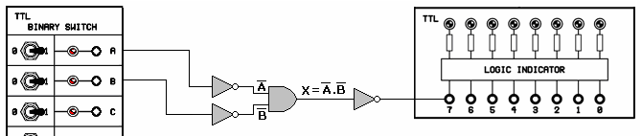
Figure 2.1
Experimental Work:
1- Construct the circuit as given in Figure 2.1 and apply the power.
2- Complete the table setting the inputs to the values in Table 2.1
A | B | INVERSE Y=A+B
0 | 0
0 | 1
1 | 0
1 | 1
Table 2.1

EXPERIMENT 2.2 LOOKING THROUGH ASSOCIATIVE LAW (OR GATE)
OBJECTIVE: To look through Associative Law: A+B+C=(A+B)+C=A+(B+C)
A*B*C=(A*B)*C=A*(B*C)
Equipments Used in the Experiment:
1- Y-0016 module.
2- Y-0016-002D
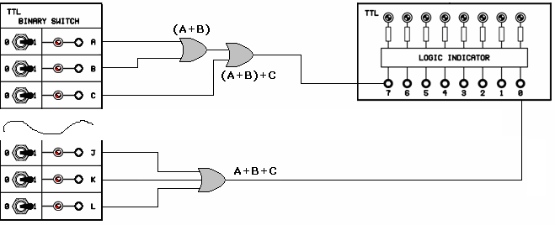
Figure 2.2
Experimental Work:
1- Construct the circuit as given in Figure 2.2 and apply the power.
2- Note the outputs according to the table.
A | B | C | A+B+C | Y=(A+B)+C
0 | 0 | 0
0 | 0 | 1
0 | 1 | 0
0 | 1 | 1
1 | 0 | 0
1 | 0 | 1
1 | 1 | 0
1 | 1 | 1
Table 2.2

EXPERIMENT 2.3 LOOKING THROUGH ASSOCIATIVE LAW (AND GATE)
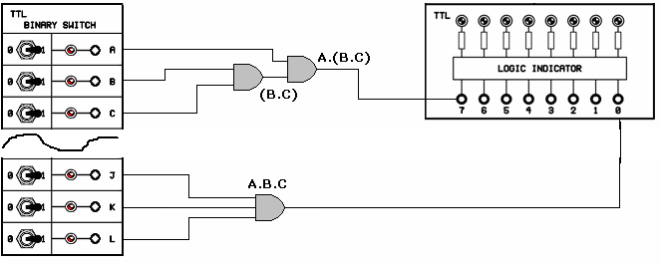
Figure 2.3
Experimental Work:
1- Construct the circuit as given in Figure 2.3 and apply the power.
2- Note the outputs according to the table.
A | B | C | A*B*C | Y=A*(B*C)
0 | 0 | 0
0 | 0 | 1
0 | 1 | 0
0 | 1 | 1
1 | 0 | 0
1 | 0 | 1
1 | 1 | 0
1 | 1 | 1
Table 2.3

EXPERIMENT 2.4 LOOKING THROUGH DISTRIBUTIVE LAW
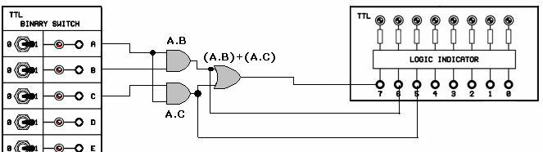
Figure 2.4
Experimental Work:
1- Construct the circuit as given in Figure 2.4 and apply the power.
2- Note the outputs according to the table 2.4.
3- Has Distributive Law Y=A*(B+C) been verified?
A | B | C | (A*B) | (A*C) | Y=(A*B)+(A*C)
0 | 0 | 0
0 | 0 | 1
0 | 1 | 0
0 | 1 | 1
1 | 0 | 0
1 | 0 | 1
1 | 1 | 0
1 | 1 | 1
Table 2.4

EXPERIMENT 2.5 LOOKING THROUGH DE MORGAN’S LAW
OBJECTIVE: To look through De Morgan’s Law: (A*B)’=A’+B’

Experimental Work:
1- Construct the circuit as given in Figure 2.5 and apply the power.
2- Note the outputs according to the table 2.5.
3- Has De Morgan’s Law (A*B)’=A’+B’ been verified?

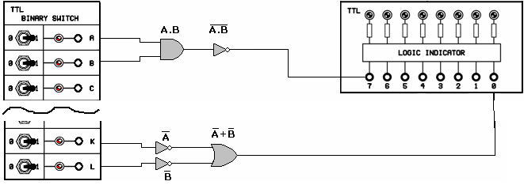
Figure 2.5
A | B | A’+B’ | (A*B)’
0 | 0
0 | 1
1 | 0
1 | 1
Table 2.5

Experiment 2.6. Realize the following circuit on a breadboard. Do not forget to connect 7th pin of 7404 chip to GND (0V) and 14th pin to VCC (+5V). Connecting X-input to either GND or VCC based on the following table, fill in the blanks. Write ON or OFF for LEDs.

 |  | INPUT | OUTPUT
 | X | LED1 | LED2
1 | 0V
2 | 5V
As a result, this truth table belongs to a(an) ……………………………. gate.

Experiment 2.7. Realize the following circuit on a breadboard. Connecting X, and Y inputs to either GND or VCC based on the following table, fill in the blanks. Write ON or OFF for LEDs, and a voltage value for F.

 |  |  | INPUTS |  | OUTPUTS
 | X | Y | LED1 | LED2 | LED3 | F (V)
1 | 0V | 0V
2 | 0V | 5V
3 | 5V | 0V
4 | 5V | 5V

As a result this truth table belongs to a(an) ……………………………………………….gate.

Experiment 2.8. Realize the following circuit on a breadboard. Do not forget to connect 7th pin of 7400 chips to GND (0V) and 14th pin to VCC (+5V). Connecting X, and Y to either GND or VCC based on the following table, fill in the blanks. Write ON or OFF for LEDs.

 |  |  | INPUTS |  | OUTPUTS
 | X | Y | LED1 | LED2 | LED3 | F (V)
1 | 0V | 0V
2 | 0V | 5V
3 | 5V | 0V
4 | 5V | 5V

As a result this truth table belongs to a(an)………………………………….gate.

Experiment 2.9. Design XNOR gate on the basis of scheme of experiment 5C, 5B and 5A. Draw the XNOR scheme with application of Scheme Design System. Realize obtained circuit on a breadboard. Do not forget to connect 7th pin of 7400 chips to GND (0V) and 14th pin to VCC (+5V). Connecting X, and Y to either GND or VCC based on the following table, fill in the blanks. Write ON or OFF for LEDs.

 |  |  | INPUTS |  | OUTPUTS
 | X | Y | LED1 | LED2 | LED3
1 | 0V | 0V
2 | 0V | 5V
3 | 5V | 0V
4 | 5V | 5V

As a result this truth table belongs to a(an)…………………………………. gate.

LABORATORY WORK #2
TEST QUESTIONS

1. Function # _____ corresponds to function XOR of 3 variables.
X | y | z | F₁ | F₂ | F₃ | F₄ | F₅
0 | 0 | 0 | 0 | 0 | 0 | 0 | 0
0 | 0 | 1 | 0 | 0 | 1 | 1 | 0
0 | 1 | 0 | 0 | 0 | 1 | 1 | 0
0 | 1 | 1 | 1 | 1 | 0 | 1 | 0
1 | 0 | 0 | 0 | 1 | 1 | 1 | 0
1 | 0 | 1 | 1 | 1 | 0 | 0 | 0
1 | 1 | 0 | 1 | 1 | 0 | 0 | 0
1 | 1 | 1 | 1 | 1 | 1 | 1 | 1

A. 1 B. 2 C. 3 D. 4 E. 5

2. Function # _____ corresponds to function OR of 3 variables.
X | y | z | F₁ | F₂ | F₃ | F₄ | F₅
0 | 0 | 0 | 0 | 0 | 0 | 0 | 0
0 | 0 | 1 | 0 | 0 | 1 | 1 | 0
0 | 1 | 0 | 0 | 0 | 1 | 1 | 0
0 | 1 | 1 | 1 | 1 | 1 | 1 | 0
1 | 0 | 0 | 0 | 1 | 1 | 1 | 0
1 | 0 | 1 | 1 | 1 | 1 | 0 | 0
1 | 1 | 0 | 1 | 1 | 1 | 0 | 0
1 | 1 | 1 | 1 | 1 | 1 | 1 | 1
A. 1 B. 2 C. 3 D. 4 E. 5

3. The truth table for NAND gate is:
A |  |  |  | B |  |  |  | C |  |  |  | D |  |  |  | E
X | y | F |  | x | y | F |  | x | y | F |  | X | y | F |  | x | y | F
0 | 0 | 0 |  | 0 | 0 | 0 |  | 0 | 0 | 1 |  | 0 | 0 | 1 |  | 0 | 0 | 0
0 | 1 | 0 |  | 0 | 1 | 1 |  | 0 | 1 | 1 |  | 0 | 1 | 0 |  | 0 | 1 | 1
1 | 0 | 0 |  | 1 | 0 | 1 |  | 1 | 0 | 1 |  | 1 | 0 | 0 |  | 1 | 0 | 1
1 | 1 | 1 |  | 1 | 1 | 1 |  | 1 | 1 | 0 |  | 1 | 1 | 0 |  | 1 | 1 | 0

4. The operator ______ is called binary operator. A. XOR B. buffer C. OR D. XNOR E. NOT

5. How many functions of 2 variables do you know? A. 4 B. 8 C. 16 D. 24 E. 32

6. XY´+X´Y is algebraic expression of ________ function.

A. XOR B. XNOR C. NOR D. NAND E. AND

7. For the gate below function F is correspondent to column ____.
F

A.1 B.2

C.3 D.4

E.5

X | Y | 1 | 2 | 3 | 4 | 5
1 | 1 | 0 | 0 | 1 | 1 | 1
1 | 0 | 1 | 0 | 1 | 0 | 0
0 | 1 | 1 | 0 | 1 | 0 | 0
0 | 0 | 1 | 1 | 0 | 0 | 1

8. XNOR can have ____ input(s).
A. 1 B.2 C.3 D.4 E. a lot of

9. AND is complement to: A. XOR B. XNOR C. NOR D. NAND E. AND

10. Apply DeMorgan’s theorem. (X+Y)`=
A. X`+Y` B. X`Y` C. (XY)` D. XY E. X+Y

LABORATORY WORK #2
TEST QUESTIONS

1. 4000 is IC of ___________ logic family.
A. TTL B. ECL C. MOS D. CMOS E. I²L

2. 14 pin TTL SSI chip can contain ___________ 3 input AND gates.
A. 1 B. 2 C. 3 D. 4 E. 5

3. Resistor has got 4 strips on its case. They are situated from the left to the right in such order: orange, orange, brown, golden. What is the nominal value of resistance?
A. 220 Ω B. 1kΩ C. 330 Ω D. 4.6 kΩ E. 10 kΩ

4. Value of resistance is 9.6 kΩ. It means that the first three strips on the resistance case (in whole the case has got 4 strips) are:
A. white, blue, red B. gray, brown, black C. Black, brown, green
D. brown, black, brown E. brown, black, red

5. The second strip to obtain resistance 120 Ω must be
A. white B. Green C. Brown D. Yellow E. red

6. The first strip to obtain resistance 5 kΩ must be
A. white B. Green C. Brown D. Yellow E. red

7. What is the output of U1A in the figure?
A. XY B. X+Y C. (X+Y)´ D. X´+Y´ E. (XY)´

8. Positive-logic OR gate is the same as negative-logic ________ gate.
A. NOR B. NAND C. AND D. XOR E. XNOR

9. Apply DeMorgan’s theorem. X`Y`
A. X`+Y` B. X+Y` C. (XY)` D. XY E. (X+Y)`

10. What statement is wrong?
A. X+X`=0 B. X+0=X C. X*1=X D. X*X`=0 E. X+1=1
LABORATORY WORK # 3

ANALYZING ADDERS AND SUBTRACTORS

Aims: investigate properties of adders and subtractors, and learn the ways of construction of adders and subtractors using logical gates. Compare experimental results with theoretical foundations about adders and subtractrors.

PREPARATION TO LAB WORK
- Learn the information about adders.
- Draw look-ahead carry generator scheme with application of Scheme Design System.
- Consider experiment’s scheme and analyze its operation. Draw it using Scheme Design System.
- Construct and draw a circuit of half-adder (for experiment 3.6) and full-adder (for experiment 3.7) using logic gates with Scheme Design System.
- Answer the questions below in written form.
  - What is a half-(full-) adder?
  - Show the truth table for half-(full-) adder.
  - Show the algebraic expressions for sum and carry for half-(full-) adder.
  - What is a binary parallel adder?
  - What is a serial adder?
  - How many adders are needed to construct 7-bit parallel adder?
  - How many bits have typical full-adders ICs got?
  - How to connect IC’s full-adders if one package is not enough?
  - What is a look-ahead carry generator?
  - What functions can look-ahead carry generator produce?

LAB WORK PERFORMANCE

- Demonstrate presence of your home preparation for lab work to your instructor.
- Pass test of 10 questions.
- Get a permission to begin the work.
- Mount the scheme of experiment 3.1 on the breadboard and perform it.
- Make a conclusion about functionality of the scheme. Compare your results with theoretical ones.
- Demonstrate your results to your instructor. If your results are correct you may dismount your scheme, if no – find the mistake.
- Repeat steps 4 to 6 for experiment 3.2 through 3.7.
- Be ready to answer your instructor’s questions in process of work.
- Complete your work, dismount your schemes, clean your working place.
- Answer your instructor’s final questions, obtain your mark.
- Ask your instructor’s permission to leave.

EXPERIMENT 3.1 ANALYZING HALF ADDER
Equipments Used in the Experiment:
1- Y-0016 main unit
2- Y-0016-005D module
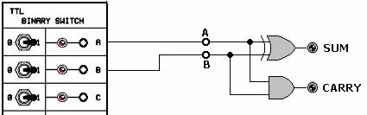
Figure 3.1

Experimental Work:
1. Construct the circuit given in Figure 3.1 and apply the power.
2. Using the switches, apply the inputs given in Table 3.1. Observe SUM and CARRY outputs and take note of them on Table 3.1

INPUTS |  | OUTPUT
A | B | SUM(S) | CARRY(C)
0 | 0
0 | 1
1 | 0
1 | 1
Table 3.1

EXPERIMENT 3.2 EXPERIMENT OF HALF-SUBTRACTOR ANALYSIS
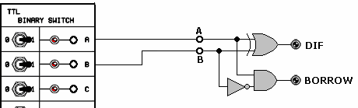
Figure 3.2

Experimental Work:
1. Construct the circuit given in Figure 3.2 and apply the power.
2. Using the switches, apply the inputs given in Table 3.2. Observe DIF and BORROW outputs from LED display and take note of them on Table 3.2

INPUTS |  | OUTPUT
A | B | BORROW(B) | DIF(D)
0 | 0
0 | 1
1 | 0
1 | 1
Table 3.2

EXPERIMENT 3.3 FULL-SUBTRACTOR ANALYSIS
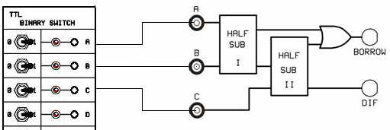
Figure 3.3
Experimental Work:
1. Construct the circuit given in Figure 3.3 and apply the power.
2. Using the switches, apply the inputs given in Table 3.3. Observe DIF and BORROW outputs from LED display and take note of them on Table 3.3
3. Has the full subtraction operation been verified?

INPUTS |  |  | OUTPUTS
C | A | B | BORROW | DIF
0 | 0 | 0
0 | 0 | 1
0 | 1 | 0
0 | 1 | 1
1 | 0 | 0
1 | 0 | 1
1 | 1 | 0
1 | 1 | 1
Table 3.3
EXPERIMENT 3.4 EXPERIMENT OF FULL ADDER ANALYSIS 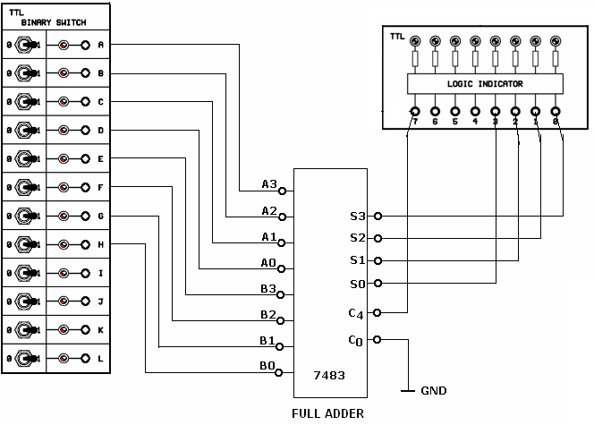
Figure 3.4
Experimental Work:
1. Construct the circuit given in Figure 3.4 and apply the power.
2. Using the switches, apply the inputs given in Table 3.4
3. Observe SUM and C4 outputs and take note of them on Table 3.4
4. Has the addition operation been verified?

1’th NUMBER |  |  |  | + | 2’nd NUMBER |  |  |  | = | C4 | OUTPUTS
A3 | A2 | A1 | A0 | + | B3 | B2 | B1 | B0 | = | C4 | S3 | S2 | S1 | S0
0 | 0 | 1 | 1 |  | 1 | 0 | 0 | 0
1 | 1 | 1 | 1 |  | 1 | 1 | 1 | 1
0 | 0 | 0 | 1 |  | 1 | 1 | 0 | 0
1 | 0 | 1 | 0 |  | 1 | 0 | 1 | 1
1 | 1 | 0 | 1 |  | 0 | 1 | 1 | 1
0 | 1 | 0 | 1 |  | 0 | 1 | 1 | 1
Table 3.4

EXPERIMENT 3.5 EXPERIMENT OF FULL ADDER ANALYSIS
Figure 3.5

Experimental Work:
1. Construct the circuit given in Figure 3.5 and apply the power.
2. Using the switches, apply the inputs given in Table 3.5.
3. Observe SUM and C4 outputs from HEX decoder and take note of them on Table 3.5
1st NUMBER |  |  |  | HEX  1st Num | + | 2nd NUMBER |  |  |  | HEX  2nd Num | = | HEX  SUM
A3 | A2 | A1 | A0 | HEX  1st Num | + | B3 | B2 | B1 | B0 | HEX  2nd Num | = | HEX  SUM
0 | 0 | 1 | 1 |  |  | 1 | 0 | 0 | 0
1 | 1 | 1 | 1 |  |  | 1 | 1 | 1 | 1
0 | 0 | 0 | 1 |  |  | 1 | 1 | 0 | 0
1 | 0 | 1 | 0 |  |  | 1 | 0 | 1 | 1
1 | 1 | 0 | 1 |  |  | 0 | 1 | 1 | 1
0 | 1 | 0 | 1 |  |  | 0 | 1 | 1 | 1
Table 3.5

EXPERIMENT 3.6
Equipments Used in the Experiment:
1- Y-0016 main unit
2- Y-0016-001D module (no pictures are required)

Experimental Work:
1. Construct the circuit of half adder, which is prepared at home, connecting inputs to binary switch and outputs to logic indicator.
2. Using the switches, apply the inputs given in Table 3.6. Observe SUM and CARRY outputs and take note of them on Table 3.6.
INPUTS |  | OUTPUT
A | B | SUM(S) | CARRY(C)
0 | 0
0 | 1
1 | 0
1 | 1
Table 3.6

EXPERIMENT 3.7
Experimental Work:
1. Construct the circuit of full adder, which is prepared at home, connecting inputs to binary switch and outputs to logic indicator.
2. Using the switches, apply the inputs given in Table3.7. Observe SUM and CARRY outputs and take note of them on Table 3.7.
INPUTS |  |  | OUTPUT
A | B | C | SUM(S) | CARRY(C)
0 | 0 | 0
0 | 0 | 1
0 | 1 | 0
0 | 1 | 1
1 | 0 | 0
1 | 0 | 1
1 | 1 | 0
1 | 1 | 1
Table 3.7

TEST QUESTIONS

1. Name the inputs_____ and outputs________ of a half-adder.
A. A₀,B₀, C_{in}, ∑₀ B. A₀,B₀, C_{out}, ∑₀ C. C_{in}, ∑₀ A₀,B₀ D. C_{out}, ∑₀ A₀,B₀,
E. ∑₀ A₀,B₀

2. The first strip to obtain resistance 220 Ω must be
A. white B. Green C. Brown D. Yellow E. red

3. What statement is wrong?
A. (X+Y)(X+Z)=X+YZ B. X(Y+Z)=XY+XZ C. X+XY=X
D. (X+Y)´=X´Y´ E. X(X+Y)=X+Y

4. A Boolean function is an expression, formed with

A. binary numbers

B. binary variables
C. binary variables and operators
D. binary variables, the two binary operators OR and AND, the unary operator NOT, parentheses, and equal sign.
E. binary variables, the binary operators OR, AND, and NOT, parentheses, and equal sign.

5. 7483 is
A. 3*8 decoder B. 4-bit magnitude comparator C. Code converter
D. 4-bit full adder E. priority encoder

6. What factor is, as a rule, more important for the circuit?
A. number of gates B. Types of gates C. Propagation delay
D. number of levels of implementation D. None of above mentioned

7. Serial binary adder consists of
A. n full adders, connected in cascade, where n-number of digits for addition
B. n half adders, connected in cascade, where n-number of digits for addition
C. n full adders and a storage device, where n-number of digits for addition
D. n half adders and a storage device, where n-number of digits for addition
E. one full adder and a storage device

8. A half-subtractor is a ________ circuit, that subtracts ________ bits and produces their difference.

A.sequential; three

B. sequential; two

C. combinational; two

D. combinational; three

E. sequential or combinational; three

9. Make addition of binary numbers: 1001 and 1010. Result is
A. 10011 B.1001 C. 1100 D. 11001 E. 10101

10. To construct 6-bit parallel adder we must use cascade of such full-adders IC s as
A. two 2-bit and one 1-bit B. one 2-bit and one 3-bit C.one 4-bit and one 1-bit
D. five 1-bit E. none of above mentioned, because 5-bit parallel adder IC exists itself
TEST QUESTIONS

1. The content of register when we enter 249 in BCD is:
A | 0 | 0 | 1 | 0 | 0 | 1 | 0 | 0 | 1 | 0 | 0 | 1
B | 0 | 0 | 1 | 0 | 0 | 1 | 0 | 0 | 1 | 0 | 0 | 0
C | 0 | 1 | 0 | 0 | 0 | 0 | 1 | 0 | 1 | 0 | 0 | 1
D | 0 | 0 | 1 | 1 | 0 | 1 | 0 | 0 | 1 | 0 | 0 | 0
E | 0 | 0 | 1 | 0 | 0 | 0 | 1 | 1 | 1 | 0 | 0 | 1

2. A small-scale integration (SSI) device contains __________ gates in a single chip.
A. thousands of B. From10 to 1000 C. More than 100

D. From 10 to 100 E. less than 10

3. Number of functions of n variables can be determined according to the formula
A. B. 2^{2n} C.2^{n} D. E. 2^{3n}

4. A half-subtractor is a ________ circuit, that subtracts ________ bits and produces their difference.

A. sequential; three

B. sequential; two

C. combinational; two

D. combinational; three

E. sequential or combinational; three

5. What is the result of the following BCD addition?
0011 0010 1001 0101
+ 0111 0000 0110
A. 0011 1001 1001 1011 B. 0100 0000 0000 0001 C. 0011 1001 1001 0001
D. 0100 0000 0000 1011 E. 0011 0000 0000 1011

6. Add in octal: 541+326
A. 967 B. 867 C. 1067 D. 947 E. 948

7. Full adder forms _________________________, but half-adder forms ___________________.
A. the sum of two bits, …. the sum of two bits and a previous carry.
B. the sum of two bits, …. the sum of two bits and a carry
C. the sum of two bits, …. the sum of two bits and a present carry

D. the sum of two bits and a carry,… the sum of two bits

E. the sum of two bits and a previous carry, … the sum of two bits

8. Add in hex: A8D5+3CA9
A. D56D B. D56E C. D46D D. E56E E. E57E

9. A Boolean function is an expression, formed with

A. binary numbers

B. binary variables
C. binary variables and operators
D. binary variables, the two binary operators OR and AND, the unary operator NOT, parentheses, and equal sign.
E. binary variables, the binary operators OR, AND, and NOT, parentheses, and equal sign

10. Equation for carry output of the second stage of look-ahead carry generator is
A. C₂=G₁+P₁C₁ B. C₂=G₁+P₁ C. C₂=G₁+C₁ D. C₂=G₁+P₂C₁ E. C₂=G₁+P₁C₂

LABORATORY WORK # 4

BCD ADDER

Aims: investigate BCD adder operation; make an addition according to the task. Compare the results of the addition with ones, made by theoretical way.

PREPARATION TO LAB WORK
- Learn the information about BCD adder and combinational logic.
- Draw block diagram of a BCD adder with application of Scheme Design System and compare this scheme with a scheme of experiment #4.
- Answer the questions below in written form.
  - What is a decimal adder?
  - What is a BCD adder?
  - For what purpose do 3 external gates exist in the scheme of BCD adder?

LAB WORK PERFORMANCE

- Demonstrate presence of your home preparation for lab work to your instructor.
- Pass test of 10 questions.
- Get a permission to begin the work.
- Mount the scheme of experiment 4A on the breadboard and perform it.
- Make a conclusion about functionality of the scheme. Compare your results with theoretical ones.
- Demonstrate your results to your instructor. If your results are correct you may dismount your scheme, if no – find the mistake.
- Repeat steps 4 – 6 for the experiment 4B.
- Be ready to answer your instructor’s questions in process of work.
- Complete your work, dismount your schemes, clean your working place.
- Answer your instructor’s final questions, obtain your mark.
- Ask your instructor’s permission to leave.

Experiment 4A. Realize the following circuit on a breadboard. Connecting A and B inputs to either GND (for 0) or VCC (for 1) based on the following table, fill in the blanks. Connect pin 5 of 7483 to VCC and pin 12 to GND. Write ON or OFF for LEDs.
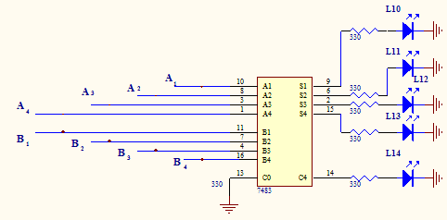

Numbers for addition |  |  |  |  |  |  |  | outputs
A1 | A2 | A3 | A4 | B1 | B2 | B3 | B4 | L 10 | L 11 | L 12 | L 13 | L 14
1 | 1 | 0 | 0 | 1 | 1 | 0 | 1
0 | 0 | 0 | 1 | 1 | 1 | 1 | 1
1 | 0 | 0 | 1 | 0 | 1 | 1 | 0

Experiment 4B. Realize the circuit on a breadboard. For 2-input AND take 7408, pins 1,2-inputs, pin 3 output. For 2-input OR take 7432, pins 1,2,4,5-inputs, pins 3,6-outputs. Fill in the tables. Connect pin 5 of 7483 to VCC and pin 12 – to GND. Connect pin 7 of 7432 and 7408 chips to GND and pin 14 to VCC. Show ONs or OFFs for LEDs.
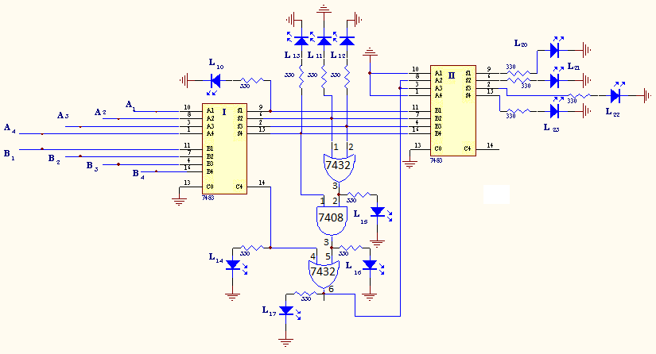

Tasks for addition:
options | Outputs of basic adder |  |  |  |  | Inputs of correction adder |  |  | Outputs of the circuit
 | L₁₀ | L₁₁ | L₁₂ | L₁₃ | L₁₄ | L₁₅ | L₁₆ | L₁₇ | L₂₀ | L₂₁ | L₂₂ | L₂₃
5+9
7+8
4+3

Conclusion:

TEST QUESTIONS

1. The content of register when we enter 249 in BCD is:
A | 0 | 0 | 1 | 0 | 0 | 1 | 0 | 0 | 1 | 0 | 0 | 1
B | 0 | 0 | 1 | 0 | 0 | 1 | 0 | 0 | 1 | 0 | 0 | 0
C | 0 | 1 | 0 | 0 | 0 | 0 | 1 | 0 | 1 | 0 | 0 | 1
D | 0 | 0 | 1 | 1 | 0 | 1 | 0 | 0 | 1 | 0 | 0 | 0
E | 0 | 0 | 1 | 0 | 0 | 0 | 1 | 1 | 1 | 0 | 0 | 1

2. A small-scale integration (SSI) device contains __________ gates in a single chip.
A. thousands of B. From10 to 1000 C. More than 100 D. From 10 to 100 E. less than 10

3. Number of functions of n variables can be determined according to the formula
A. B. 2^{2n} C.2^{n} D. E. 2^{3n}

4. A half-subtractor is a ________ circuit, that subtracts ________ bits and produces their difference.

A.sequential; three B. sequential; two C. combinational; two

D. combinational; three E. sequential or combinational; three

5. What is the result of the following BCD addition?
0011 0010 1001 0101
+ 0111 0000 0110

A. 0011 1001 1001 1011 B. 0100 0000 0000 0001 C. 0011 1001 1001 0001
D. 0100 0000 0000 1011 E. 0011 0000 0000 1011

6. Add in octal: 541+326
A. 967 B. 867 C. 1067 D. 947 E. 948

7. Full adder forms ____________, but half-adder forms _________________________.
A. the sum of two bits, …. the sum of two bits and a previous carry.
B. the sum of two bits, …. the sum of two bits and a carry
C. the sum of two bits, …. the sum of two bits and a present carry
D. the sum of two bits and a carry,… the sum of two bits

E. the sum of two bits and a previous carry, … the sum of two bits

8. Add in hex: A8D5+3CA9
A. D56D B. D56E C. D46D D. E56E E. E57E

9. A Boolean function is an expression, formed with

A. binary numbers

B. binary variables
C. binary variables and operators
D. binary variables, the two binary operators OR and AND, the unary operator NOT, parentheses, and equal sign.
E. binary variables, the binary operators OR, AND, and NOT, parentheses, and equal sign

10. Equation for carry output of the second stage of look-ahead carry generator is
A. C₂=G₁+P₁C₁ B. C₂=G₁+P₁ C. C₂=G₁+C₁ D. C₂=G₁+P₂C₁ E. C₂=G₁+P₁C₂

LABORATORY WORK # 5

MULTIPLEXER, DEMULTIPLEXER AND BINARY COMPARATOR

Aims: investigate multiplexer, demultiplexer and binary comparator operation; make examples of data selection, data transfer and data comparison according to the task. Compare the results with ones, made by theoretical way.

PREPARATION TO LAB WORK
- Learn the information about multiplexer, demultiplexer and binary comparator.
- Consider experiment’s schemes and analyze their operation. Draw them using Scheme Design System.
- Fill in the tables theoretically.
- Draw the scheme which is suitable to define if 4-bit binary number A is equal to the 4-bit binary number B or not (use Scheme Design System).
- Show the principal scheme of 2*4 decoder with application of Scheme Design System.
- Answer the questions below in written form.
  - What is magnitude comparator?
  - How many output signals may exist for magnitude comparator simultaneously and why?
  - Why A<B, A>B inputs of the first 7485 must be grounded, and A=B input must be HIGH?
  - What are a decoder and DUX, show differences?
  - What is functionality of enable input of a decoder?
  - What is an encoder?
  - What is a priority encoder?
  - Compare decoder and encoder.
  - What is a MUX?
  - How many functions can a MUX realize?
  - What is a role of a MUX’s selection lines?
  - Compare DUX and MUX.

LAB WORK PERFORMANCE

- Demonstrate presence of your home preparation for lab work to your instructor.
- Pass test of 10 questions.
- Get a permission to begin the work.
- Mount the scheme of experiment 5.1 on the breadboard and perform it.
- Make a conclusion about functionality of the scheme. Compare your results with theoretical ones.
- Demonstrate your results to your instructor. If your results are correct you may dismount your scheme, if no – find the mistake.
- Repeat steps 4 – 6 for the experiments 5.2 through 5.4.
- Be ready to answer your instructor’s questions in process of work.
- Complete your work, dismount your schemes, and clean your working place.
- Answer your instructor’s final questions, obtain your mark.
- Ask your instructor’s permission to leave.

EXPERIMENT 5.1 EXPERIMENT OF 8 X 1 MULTIPLEXER (MUX)
Equipments Used in the Experiment:
1- Y-0016 main unit
2- Y-0016-009D module
Figure 5.1

Experimental Work:
1. Connect the circuit as shown in figure 5.1 and apply the power.
2. Apply the inputs given in Table 5.1 using the switches. Use one of the following input combinations provided by your instructor for D0-D7 inputs: a) 10110010; b) 01010101; c) 00011100; d) 11101110. Observe the Y and Y’ outputs from LED display and note them on the table 8.1
3. Have the inputs been transferred to the output Y?
DATA SELECT |  |  | E’ | INPUTS |  |  |  |  |  |  |  | OUTPUTS
S2 | S1 | S0 | E’ | D0 | D1 | D2 | D3 | D4 | D5 | D6 | D7 | Y | Y’
X | X | X | 1 | X | X | X | X | X | X | X | X
0 | 0 | 0 | 0
0 | 0 | 1 | 0
0 | 1 | 0 | 0
0 | 1 | 1 | 0
1 | 0 | 0 | 0
1 | 0 | 1 | 0
1 | 1 | 0 | 0
1 | 1 | 1 | 0
Table 5.1

EXPERIMENT 5.2 EXPERIMENT OF 1 X 8 DE-MULTIPLEXER (DUX)
Equipments Used in the Experiment:
1- Y-0016 main unit
2- Y-0016-009D module
Figure 5.2

Experimental Work:
1. Connect the circuit as shown in figure 5.2 and apply the power.
2. Apply the inputs given in Table 5.2 using the switches. Observe the D outputs from LED display and note them on the table 5.2
3. Have the input Y been transferred to the outputs D0-D7?
INPUTS |  |  |  |  |  | OUTPUTS
S2 | S1 | S0 | E’ | Y | Y’ | D0 | D1 | D2 | D3 | D4 | D5 | D6 | D7
0 | 0 | 0 | 0 | 1 | 0
0 | 0 | 1 | 0 | 1 | 0
0 | 1 | 0 | 0 | 1 | 0
0 | 1 | 1 | 0 | 1 | 0
1 | 0 | 0 | 0 | 1 | 0
1 | 0 | 1 | 0 | 1 | 0
1 | 1 | 0 | 0 | 1 | 0
1 | 1 | 1 | 0 | 1 | 0
Table 5.2

EXPERIMENT 5.3 EXPERIMENT OF DATA TRANSFER GATE (MUX-DUX COMBINATION)
Equipments Used in the Experiment:
1- Y-0016 main unit
2- Y-0016-009D module
Figure 5.3
Experimental Work:
1. Connect the circuit as given in figure 5.3 and apply the power.
2. Apply the inputs given in table 5.3 using the switches. Use one of the following input combinations provided by your instructor for D0-D7 inputs: a) 10110010; b) 01010101; c) 00011100; d) 11101110. Fill in the table 8.3 by observing outputs D0-D7 from LED display.

NOTE: Don’t forget to combine the pins S0-S1-S2 and E’; so that the ICs will operate synchronously.

3. Have the data at the input been transferred to the output?

MUX & DUX INPUTS |  |  |  | DATA INPUTS |  |  |  |  |  |  |  | DATA OUTPUTS
S2 | S1 | S0 | E' | D0 | D1 | D2 | D3 | D4 | D5 | D6 | D7 | D0 | D1 | D2 | D3 | D4 | D5 | D6 | D7
0 | 0 | 0 | 0
0 | 0 | 1 | 0
0 | 1 | 0 | 0
0 | 1 | 1 | 0
1 | 0 | 0 | 0
1 | 0 | 1 | 0
1 | 1 | 0 | 0
1 | 1 | 1 | 0
Table 5.3
Experiment 5.4 Prepare the circuit on the breadboard. Do not forget to connect pin 8 of the 7485 chip to the GROUND and pin 16 to VCC. Apply the signals according to the table below. Fill in the table 5.4 by connecting inputs according to the table 5.4 and observing output LEDs.

Inputs |  |  |  |  |  |  |  |  |  |  |  |  |  |  |  | outputs
A₇ | A₆ | A₅ | A₄ | A₃ | A₂ | A₁ | A₀ | B₇ | B₆ | B₅ | B₄ | B₃ | B₂ | B₁ | B₀ | A<B | A>B | A=B
0 | 0 | 0 | 0 | 0 | 0 | 0 | 0 | 0 | 0 | 0 | 0 | 0 | 0 | 0 | 0
0 | 0 | 0 | 0 | 0 | 0 | 0 | 1 | 0 | 0 | 0 | 0 | 0 | 0 | 0 | 0
0 | 0 | 0 | 0 | 0 | 0 | 0 | 1 | 0 | 0 | 0 | 0 | 0 | 0 | 0 | 1
0 | 1 | 1 | 0 | 1 | 1 | 0 | 0 | 0 | 1 | 1 | 0 | 0 | 1 | 0 | 0
0 | 1 | 1 | 0 | 1 | 1 | 0 | 0 | 1 | 1 | 1 | 0 | 0 | 1 | 0 | 0
1 | 1 | 1 | 1 | 1 | 1 | 1 | 1 | 1 | 1 | 1 | 1 | 1 | 1 | 1 | 1
1 | 1 | 1 | 1 | 1 | 1 | 1 | 0 | 1 | 1 | 1 | 1 | 1 | 1 | 1 | 1
Table 5.4

TEST QUESTIONS
1. A decoder is a combinatioal circuit that
A. converts binary information from n input lines to a maximum of 2^{n} unique output lines
B. has 2^{n} (or less) unique input lines and n output lines
C. selects binary information from one of many input lines and direct it to a single output line
D. receives information on a single line and transmits this information on one of 2^{n} possible output lines

E. converts binary information from n input lines to m output lines

2. Output of 1*4 demultiplexer is D₁. What are selection lines?
A. 00 B. 01 C. 10 D. 11 E. any of them

3. What signals for XYZ inputs are applied if active output is D₀?
A.0, 0, 0 B. 0, 1, 1 C. 1, 0, 0 D. 0, 1, 0 E. 0, 0, 1

4. DUX sometimes is called

A. code converter B. data selector C. data distributor
D. decoder E. all answers are correct

5. For the circuit below if EI=5V, D1=0, D5=0 the state of L1 to L5 will be

A. ON,ON,ON,ON,ON B. OFF,OFF,OFF,ON,ON

C. ON,ON,ON,OFF,OFF D. OFF,OFF, ON,ON,ON,

E. OFF, ON,ON,ON, OFF

6. For priority encoder we have got input lines D₁, D₃, and D₆ active simultaneously. In such case output signal will be corresponded to … A. D₁ B. D₃ C. D₆ D. D₁or D₃ E. D₃ or D₆

7. Decoder is __________ component.
A. SSI B. MSI C. LSI D. VLSI E. SSI or MSI

8. For the circuit below if selection lines S₂S₁S₀=011 the output Z will be ____, if S₂S₁S₀=100, Z will be ____, if S₂S₁S₀=001, Z will be ____.
A. 1,1,0 B. 0,1,1 C. 1,1,1 D. 0,1,0 E.1,0,1

9. For the circuit in question 8 the output Z is equal to _____ for periods of time between t₃ and t₄, t₄ and t₅, t₅ and t₆.
A. 0,1,1 B. 0,1,0 C. 1,1,1 D. 0,0,1 E. 1,0,1

10. What function is implemented with multiplexer?
A. F(A,B,C,D)= Σ(0,1,3,4,5,8,15) B. F(A,B,C,D)= Σ(0,1,3,4,7,14)
C. F(A,B,C,D)= Σ(0,1,3,4,8,15) D. F(A,B,C,D)= Σ(0,1,3,4,8,9,15)
E. F(A,B,C,D)= Σ(0,1,3,5,7,14,15)
LABORATORY WORK # 6

FLIP-FLOPS

Aims: investigate operation of different types of flip-flops; make experiments of setting and resetting a data on a flip-flop, and investigate a data storage property of a flip-flop. Compare the results with ones, made by theoretical way.

PREPARATION TO LAB WORK
- Learn the information about flip-flop and sequential circuits.
- Consider experiment’s schemes and analyze their operation. Draw them using Scheme Design System.
- Fill in the tables theoretically.
- Draw the scheme of RS, JK, D and T flip-flops with CLK input. (Use Scheme Design System).
- Answer the questions below in written form.
  - What circuit is called sequential?
  - What sequential circuit is called synchronous?
  - What sequential circuit is called asynchronous?
  - What is a master-clock generator?
  - What circuits are called clocked sequential circuits?
  - What is a flip-flop?
  - What types of flip-flops do you know?
  - Show truth tables for all types of flip-flops.
  - What is a master-slave flip-flop?
  - What is setup time and hold time for flip-flop?
  - Show excitation tables for all types of flip-flops.
  - What types of flip-flops’ triggering do you know?

LAB WORK PERFORMANCE

- Demonstrate presence of your home preparation for lab work to your instructor.
- Pass test of 10 questions.
- Get a permission to begin the work.
- Mount the scheme of experiment 6.1 on the breadboard and perform it.
- Make a conclusion about functionality of the scheme. Compare your results with theoretical ones.
- Demonstrate your results to your instructor. If your results are correct you may dismount your scheme, if no – find the mistake.
- Repeat steps 4 – 6 for the experiments 6.2 through 6.10.
- Be ready to answer your instructor’s questions in process of work.
- Complete your work, dismount your schemes, and clean your working place.
- Answer your instructor’s final questions, obtain your mark.
- Ask your instructor’s permission to leave.

6.1 EXPERIMENT NAME: R-S FLIP-FLOP WITH NOR GATES
Equipments Used in the Experiment:
1- Y-0016 main unit
2- Y-0016-003D module
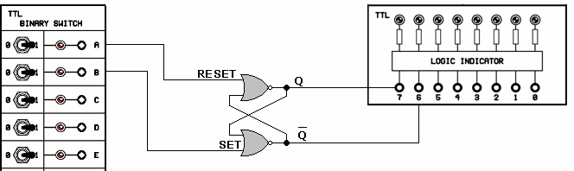
Figure 6.1

Experimental Work :
1. Construct the circuit as given in Figure 6.1 and apply the power.
2. Using the switches A and B, apply the input values of S and R as given in Table 6.1. Investigate the Q outputs by a LED display and take notes of them in the Table 6.1.
3. According to the results in Table 6.1:
a) Are the outputs always inverse of each other?
b) Compare the results in the table with the knowledge given in Pre-Info. Are they consistent?
ORDER | INPUT |  | OUTPUT
ORDER | S | R | Q | Q’
1 | 0 | 1
2 | 0 | 0
3 | 1 | 0
4 | 0 | 0
5 | 0 | 1
6 | 0 | 0
7 | 1 | 0
8 | 1 | 1
Table 6.1

EXPERIMENT 6.2 R-S FLIP-FLOP WITH CLOCK
Equipments Used in the Experiment:
1- Y-0016 main unit
2- Y-0016-003D module
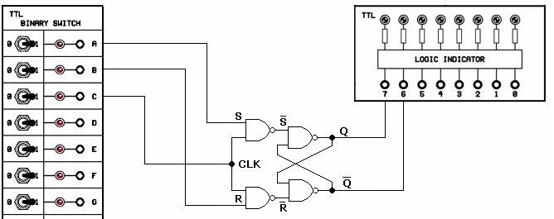
Figure 6.2

Experimental Work:
1. Construct the circuit as given in Figure 6.2 and apply the power.
2. Using the switches A and B, apply the input values of S and R as given in Table 6.2. Investigate the Q outputs by a LED display and take notes of them in the Table 6.2.
3. When does the change in inputs S-R affect the output? Explain
CLK | INPUT |  | OUTPUT
CLK | S | R | Q | Q’
1 | 1 | 0
0 | 1 | 0
0 | 0 | 0
1 | 0 | 0
0 | 0 | 1
1 | 0 | 1
0 | 0 | 1
0 | 0 | 0
1 | 0 | 0
0 | 1 | 1
1 | 1 | 1
Table 6.2

EXPERIMENT 9.3 OBTAINING TRUTH TABLE OF THE J-K FLIP-FLOP
Equipments Used in the Experiment:
1- Y-0016 main unit
2- Y-0016-003D module
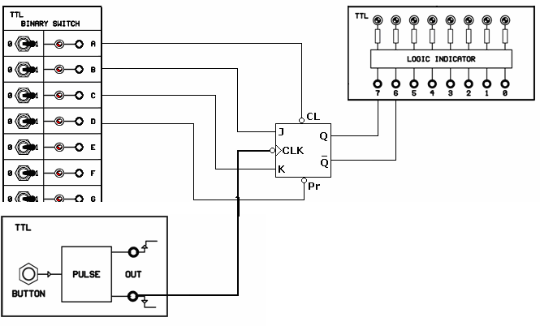
Figure 6.3

Experimental Work:
1. Construct the circuit as given in Figure 6.3 and apply the power.
2. Observe the output Q using the inputs Preset, Clear, J, K and CLK, and take note of the output levels to the related part of the table. The places having (X) are Don't Care places. They can be 1 or 0.
NOTE: The CLK pulse should be given the last!
3. According to the results in Table 6.3:
a) When both J and K are 0 and when CLK pulse occurs, does the FF preserve its previous state?
b) When the CLK input falls from 1 to 0, does it trigger FF?
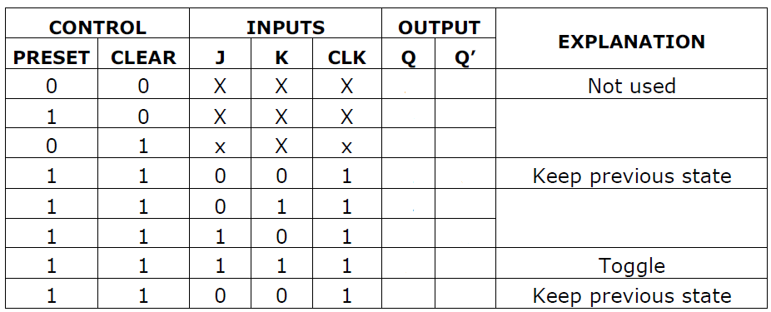
Table 6.3

EXPERIMENT 9.4 OBTAINING TRUTH TABLE OF THE D FLIP-FLOP
Equipments Used in the Experiment:
1- Y-0016 main unit
2- Y-0016-003D module
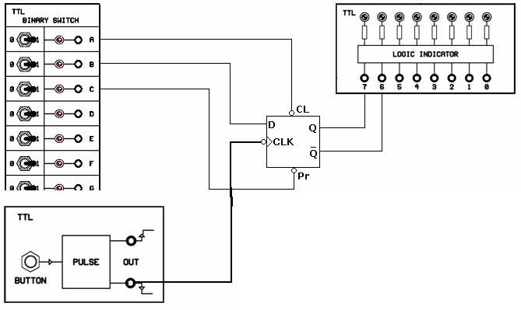
Figure 6.4
Experimental Work:
1. Construct the circuit as given in Figure 6.4, and apply the power.
2. Fill in Table 6.4 by using the Preset, Clear, CLK and D levels in Table 6.4.
NOTE: D input should always be provided before the CLK input.
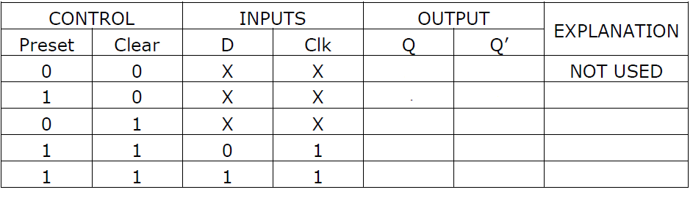
Table 6.4

EXPERIMENT 6.5 OBTAINING D FLIP-FLOP USING J-K FLIP-FLOP
Equipments Used in the Experiment:
1- Y-0016 main unit
2- Y-0016-003D module and Y-0016-001D module
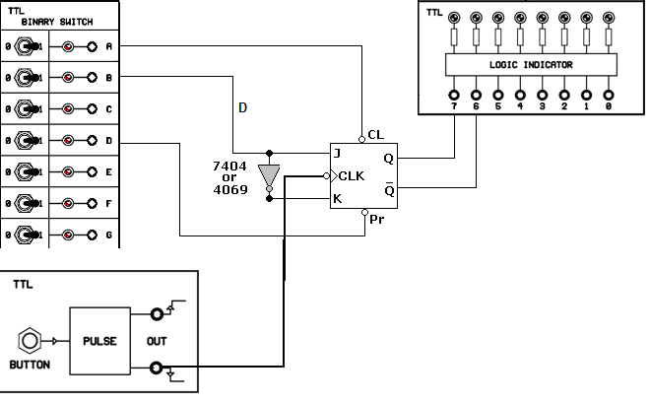
Figure 6.5
Experimental Work:
1. Construct the circuit as given in Figure 9.5, and apply the power.
2. Fill in Table 6.5 by using the Preset, CLK and D levels in Table 6.5.
NOTE: D input should always be provided before the CLK input.
Table 6.5

6.6 EXPERIMENT NAME: R-S FLIP-FLOP WITH NOR GATES
Equipments Used in the Experiment:
1- Y-0016 main unit
2- Y-0016-001D module
Figure 6.6

Experimental Work:
1. Construct the circuit as given in Figure 6.6 and apply the power.
2. Using the switches A and B, apply the input values of S and R as given in Table 6.6. Investigate the Q outputs by a LED display and take notes of them in the Table 6.6.
3. Compare the results in the table with the knowledge given in Pre-Info. Are they consistent?
ORDER | INPUT |  | OUTPUT
ORDER | S | R | Q | Q’
1 | 0 | 1
2 | 0 | 0
3 | 1 | 0
4 | 0 | 0
5 | 0 | 1
6 | 0 | 0
7 | 1 | 0
8 | 1 | 1
Table 6.6

EXPERIMENT 6.7 R-S FLIP-FLOP WITH NAND GATES
Equipments Used in the Experiment:
1- Y-0016 main unit
2- Y-0016-001D module
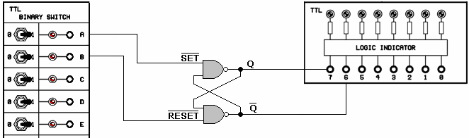
Figure 6.7

Experimental Work:
1. Construct the circuit as given in Figure 6.7 and apply the power.
2. Using the switches A and B, apply the input values of S and R as given in Table 6.7 Investigate the Q outputs by a LED display and take notes of them in the Table 6.7.
ORDER | INPUT |  | OUTPUT
ORDER | S | R | Q | Q’
1 | 0 | 1
2 | 1 | 1
3 | 1 | 0
4 | 1 | 1
5 | 0 | 1
6 | 1 | 1
7 | 1 | 0
8 | 0 | 0
Table 6.7

EXPERIMENT 6.8 R-S FLIP-FLOP WITH CLOCK
Equipments Used in the Experiment:
1- Y-0016 main unit
2- Y-0016-001D module
Figure 6.8

Experimental Work:
1. Construct the circuit as given in Figure 6.8 and apply the power.
2. Using the switches A, B, C apply the input values of S and R as given in Table 6.8. Investigate the Q outputs by a LED display and take notes of them in the Table 6.8.
3. When does the change in inputs S-R affect the output? Explain
CLK | INPUT |  | OUTPUT
CLK | S | R | Q | Q’
1 | 1 | 0
0 | 1 | 0
0 | 0 | 0
1 | 0 | 0
0 | 0 | 1
1 | 0 | 1
0 | 0 | 1
0 | 0 | 0
1 | 0 | 0
0 | 1 | 1
1 | 1 | 1
Table 6.8

EXPERIMENT 6.9 R-S FLIP-FLOP WITH CLOCK
Equipments Used in the Experiment:
1- Y-0016 main unit
2- Y-0016-002D module

Experimental Work:
1. Construct the circuit as given in Figure 6.9 and apply the power.
2. Using the switches A, B, C, D, E apply the input values of S, R, CLK, Preset, Clear as given in Table 6.9. Investigate the Q outputs by a LED display and take notes of them in the Table 6.9.
3. When does the change in inputs S-R affect the output? Explain
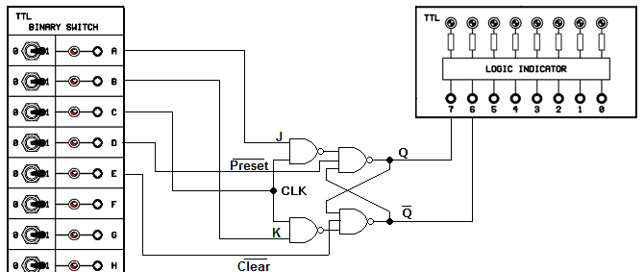
Figure 6.9

Preset | Clear | CLC | INPUT |  | OUTPUT
Preset | Clear | CLC | J | K | Q | Q’
0 | 0 | X | X | X
0 | 1 | X | X | X
1 | 0 | X | X | X
1 | 1 | 1 | 0 | 0
1 | 1 | 0 | 1 | 0
1 | 1 | 1 | 1 | 0
1 | 1 | 0 | 0 | 0
1 | 1 | 1 | 0 | 0
1 | 1 | 0 | 0 | 1
1 | 1 | 1 | 0 | 1
1 | 1 | 0 | 1 | 1
1 | 1 | 1 | 1 | 1
1 | 1 | 0 | 1 | 1
1 | 1 | 1 | 1 | 1
Table 9.9

EXPERIMENT 6.9 D FLIP-FLOP WITH CLOCK
Equipments Used in the Experiment:
1- Y-0016 main unit
2- Bread Board

Experimental Work:
Realize the following circuit shown in figure 6.10 on a breadboard. Connecting D, CLK, CD, and SD inputs to either GND or VCC based on the table 6.10, fill in the blanks. Don’t forget to connect 7th pin of 7474 chip to GND and 14th pin to VCC. Write ON or OFF for LEDs in Table 6.10.
Figure 6.10

 |  |  |  |  | INPUTS |  |  |  | OUTPUTS
 | D | CLK | CD | SD | LED1 | LED2 | LED3 | LED4 | LED5 | LED6
1 | 0V | 0V | 5V | 5V
2 | 0V | 5V | 5V | 5V
3 | 0V | 0V | 5V | 5V
4 | 5V | 0V | 5V | 5V
5 | 5V | 5V | 5V | 5V
6 | 5V | 0V | 5V | 5V
7 | 5V | 0V | 0V | 5V
8 | 5V | 0V | 5V | 5V
9 | 5V | 0V | 5V | 0V
10 | 5V | 0V | 5V | 5V
11 | 5V | 0V | 0V | 5V
12 | 5V | 0V | 5V | 5V
13 | 5V | 0V | 5V | 0V
14 | 5V | 0V | 5V | 5V
15 | 0V | 0V | 5V | 5V
16 | 0V | 0V | 0V | 5V
17 | 0V | 0V | 5V | 5V
18 | 0V | 0V | 5V | 0V
19 | 0V | 0V | 5V | 5V
20 | 0V | 5V | 5V | 5V
21 | 0V | 0V | 5V | 5V
22 | 0V | 0V | 0V | 5V
23 * | 0V | 0V | 0V | 0V
24 | 0V | 0V | 5V | 0V
25 | 0V | 0V | 5V | 5V
Table 6.10
* be careful at that stage!
Based on the above truth table, it is a ………. type flip flop, with ……… is the input, …….. is the clock input, ……….. is the output, and ……… is the inverting output. SD is ………………………… and CD is …………………………
TEST QUESTIONS

1. ________ flip-flop gives us uncertainty if set and reset inputs have value 1 at the same time.

A. RS and clocked RS B.RS or clocked RS C. D D. JK E. T

2. This is characteristic table of _____ flip-flop.
Q (t+1)
X
B
C
J
Q
K
CLR
A
FJKC
Z
CP
Y
0 | 0
1 | 1
A. RS B. Clocked RS C. D D. JK E. T

3. This is excitation table of _______ flip-flop.
Q(t) | Q (t+1)
0 | 0 | 0 | X
0 | 1 | 1 | X
1 | 0 | X | 1
1 | 1 | X | 0

A. RS B. Clocked RS C. D D. JK E. T

4. What state sequence for Q(t+1) is correct?
J | K | Q (t+1)
0 | 0
0 | 1
1 | 0
1 | 1
A. 1, 0, Q(t), ? B. 1, 0,?, Q(t) C. Q(t), 0,1,Q´(t) D. Q(t), 0,1, 1 E. Q(t), 0,1, 0

5. Set-dominate flip-flop has got ______ input(s). A. 1 B. 2 C. 1 or 2 D. 3 E. 2 or 3

6. D flip-flop characteristic equation is _____
A. Q(t+1)=DQ B. Q(t+1)=D+Q C. Q(t+1)=D D. Q(t+1)=D´Q E. Q(t+1)=D´

7. A state equation of the sequential circuit is

A. an expression to describe next state of the circuit
B. an expression to describe present state of the circuit
C. a Boolean function that specifies the present state conditions
D. a Boolean function that specifies the present state conditions that make the next state equal to 1
E. a Boolean function that specifies the next state conditions that make the present state equal to 1

8. How many options to gain state 10 will the circuit with the state table below have?
Present state |  | Next state
 |  | X=0 |  | X=1
A | B | A | B | A | B
0 | 0 | 0 | 1 | 1 | 1
0 | 1 | 1 | 0 | 0 | 0
1 | 0 | 0 | 0 | 0 | 0
1 | 1 | 0 | 1 | 1 | 0

A. 1 B. 2 C. 3 D. 4 E. 5

9. What is the input equation for D flip-flop for the circuit below?

A. A+X

B. A⊕X

C. A⊕X⊕Y

D. X⊕Y

E. X⊕YA

10. For the circuit below X=1,B=1,Y=1,C=1. What will be the next state for the flip-flop?
A. set B. reset C. complement D. No change E. none

LABORATORY WORK # 7

COUNTERS AND REGISTERS

Aims: investigate operation of different types of counters and registers; make experiments of setting and resetting a data on a registers, and investigate a data storage property of a register. Investigate up and down counter. Compare the results with ones, made by theoretical way.

PREPARATION TO LAB WORK
- Learn the information about counters, registers and sequential circuits.
- Consider experiment’s schemes and analyze their operation. Draw them using Scheme Design System.
- Fill in the tables theoretically.
- Answer the questions below in written form.
  - What is a word-time signal?
  - What is a ring counter?
  - What is switch tail ring counter?
  - What is ripple counter?
  - What is BCD counter?
  - What is the difference between synchronous and asynchronous counters?
  - What is register?
  - What types of registers do you know?
  - Explain parallel-in serial-out register.
  - What is seven-segment-display driver?

LAB WORK PERFORMANCE

- Demonstrate presence of your home preparation for lab work to your instructor.
- Pass test of 10 questions.
- Get a permission to begin the work.
- Mount the scheme of experiment 7.1 on the breadboard and perform it.
- Make a conclusion about functionality of the scheme. Compare your results with theoretical ones.
- Demonstrate your results to your instructor. If your results are correct you may dismount your scheme, if no – find the mistake.
- Repeat steps 4 – 6 for the experiments 7.2 through 7.11.
- Be ready to answer your instructor’s questions in process of work.
- Complete your work, dismount your schemes, and clean your working place.
- Answer your instructor’s final questions, obtain your mark.
- Ask your instructor’s permission to leave.
7.1 EXPERIMENT NAME: BINARY COUNTER
Equipments Used in the Experiment:
1- Y-0016 main unit.
2- Y-0016-004D module
.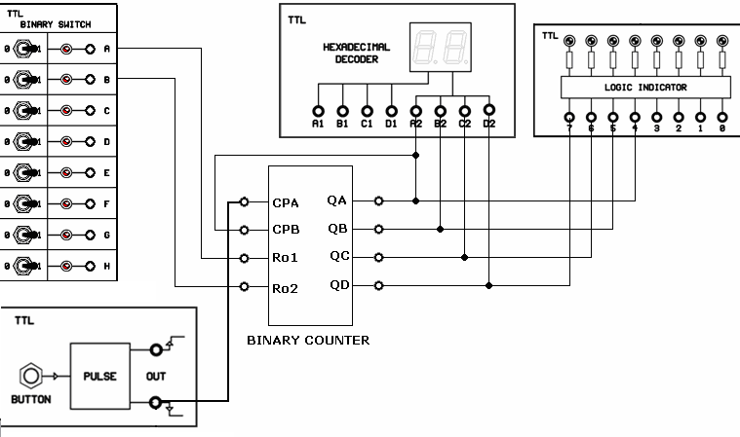
Figure 7.1

Experimental Work:
1. Construct the circuit of Figure 7.1 and apply the power.
2. Connect the switches according to Figure 7.1, apply the inputs given in the table and observe the output from LED and Display. Fill in the table.

CPA | Ro1 | Ro2 | Q0 | Q1 | Q2 | Q3 | HEX-DEC
0 | 1 | 1
1 | 0 | 0
2 | 0 | 0
3 | 0 | 0
4 | 0 | 0
5 | 0 | 0
6 | 0 | 0
7 | 0 | 0
8 | 0 | 0
9 | 0 | 0
10 | 0 | 0
11 | 0 | 0
12 | 0 | 0
13 | 0 | 0
14 | 0 | 0
15 | 0 | 0
Table 7.1

NOTE: Since the counter is not reset when input RO1 and RO2 are “0”, it continues counting. If they are 1, counter is reset and counting starts from 1.

EXPERIMENT 7.2 USING BINARY COUNTER AS A BCD COUNTER
Equipments Used in the Experiment:
1- Y-0016 main unit.
2- Y-0016-004D module
Figure 7.2

Experimental Work:
1. Construct the circuit of Figure 7.2 and apply the power.
2. Observe the output from the LED and Display. Fill in the table.

CLC | Q0 | Q1 | Q2 | Q3 | DECIMAL
0
1
2
3
4
5
6
7
8
9
10
11
12
13
14
15
Table 7.2

NOTE: The counting limit of the counter can be adjusted by setting RO1 (MR1) and RO2 (MR2). Since it is desired the counter to count between 0-9, the limit is adjusted to 10. Thus BCD counting is achieved.
EXPERIMENT 7.3 ANALYZING 7 BIT BINARY COUNTER
Equipments Used in the Experiment:
1- Y-0016 main unit.
2- Y-0016-004D module
Figure 7.3
Experimental Work:
1. Construct the circuit in Figure 7.3 and apply the power.
2. According to the table, observe the output from LED and Display. Fill in the table.
3. Up to which value can the circuit count?
INPUTS |  | OUTPUTS
CLK | MR | Q6 | Q5 | Q4 | Q3 | Q2 | Q1 | Q0 | DECIMAL
0 | 0
1 | 0
2 | 0
3 | 0
4 | 0
5 | 0
6 | 0
7 | 0
8 | 0
9 | 0
10 | 0
11 | 0
12 | 0
13 | 0
14 | 0
15 | 0
20 | 0
25 | 0
30 | 0
35 | 0
Table 7.3 (Part 1)
INPUTS |  | OUTPUTS
CLK | MR | Q6 | Q5 | Q4 | Q3 | Q2 | Q1 | Q0 | DECIMAL
40 | 0
45 | 0
50 | 0
55 | 0
60 | 0
65 | 0
70 | 0
75 | 0
80 | 0
85 | 0
90 | 0
95 | 0
100 | 0
105 | 0
110 | 0
115 | 0
120 | 0
125 | 0
126 | 0
127 | 0
Table 7.3 (Part 2)

EXPERIMENT 7.4 ANALYZING ASYNCHRONOUS UP-COUNTERS COMPOSED OF JK FLIP-FLOPS
Figure 7.4

Experimental Work:
1. Construct the circuit of Figure 10.4. Set the PR' and CLR' pins to "1"
2. Set the CLR' pin to "0" to clear the outputs. Set CLR' pin back to "1" again. QA corresponds to LSB and QD corresponds to MSB. The JK FFs are in the T operation state. Why?
3. Press the PULSE button once. Explain the change in the outputs.
4. Complete Table 10.4 according to the pulse order.
PULSE | OUTPUTS |  |  |  | HEX | DECIMAL  EQUIVALENT
PULSE | QD | QC | QB | QA | HEX | DECIMAL  EQUIVALENT
CLEAR=0
0
1
2
3
4
5
6
7
8
9
10
11
12
13
14
15
16
17
18
Table 7.4

7.5 EXPERIMENT NAME: ANALYZING ASYNCHRONOUS DOWN-COUNTERS COMPOSED OF JK FLIP-FLOPS Equipments Used in the Experiment:
1- Y-0016 main unit.
2- Y-0016-004D module

Experimental Work:
1. Construct the circuit of Figure 7.5 and apply the power. Set Clr pin to “1”.
2. Set Pr' input first to "0" then to "1". What are the outputs? Why?
3. Apply the first clock pulse to the counter input by pressing the PULSE button. Explain the outputs.
4. Complete Table 7.5. What kind of a counting does the counter do? Why?
5. What is the modulo of the counter?

Figure 7.5

PULSE | OUTPUTS |  |  |  | HEX  EQUIVALENT | DECIMAL  EQUIVALENT
PULSE | QD | QC | QB | QA | HEX  EQUIVALENT | DECIMAL  EQUIVALENT
PRESET=1
0
1
2
3
4
5
6
7
8
9
10
11
12
13
14
15
16
17
18
Table 7.5

EXPERIMENT 7.6 DETERMINING COUNTING LIMITS OF THE ASYNCH. COUNTERS
Figure 7.6

Experimental Work:
1. Construct the circuit of Figure 7.6 and apply the power.
2. Set the Preset' input (A Switch) to "1".
3. Press the PULSE button until the FF outputs are all "0".
4. What is the modulo of the counter? Why?
PULSE | OUTPUTS |  |  |  | DECIMAL  EQUIVALENT
PULSE | QD | QC | QB | QA | DECIMAL  EQUIVALENT
CLEAR=0
0
1
2
3
4
5
6
7
8
9
10
11
12
Table 7.6

EXPERIMENT 7.7 EXPERIMENT OF SHIFT REGISTERS COMPOSED OF FLIP-FLOPS
Equipments Used in the Experiment:
1- Y-0016 main unit
2- Y-0016-006D module
Figure 7.7

Experimental Work:
1. Construct the circuit as given in Figure 7.7 and apply the power.
2. By applying SET, RESET, Clk and D values given in Table 7.7, fill in the table.
NOTE: D input must always be applied before Clk.
INPUT |  |  |  | OUTPUT
Clk | RESET(R) | SET (S) | D | Q0 | Q1 | Q2 | Q3
X | 1 | 0 | X
X | 0 | 1 | X
1 | 1 | 1 | 1
2 | 1 | 1 | 1
3 | 1 | 1 | 1
4 | 1 | 1 | 1
5 | 1 | 1 | 0
6 | 1 | 1 | 0
7 | 1 | 1 | 0
8 | 1 | 1 | 0
9 | 1 | 1 | 1
10 | 1 | 1 | 0
11 | 1 | 1 | 0
Table 7.7

EXPERIMENT 7.8 EXPERIMENT OF RIGHT SHIFT REGISTERS
Equipments Used in the Experiment:
1- Y-0016 main unit
2- Y-0016-006D module
Figure 7.8

Experimental Work:
1. Construct the circuit as given in Figure 10.8 and apply the power.
2. Set S0=1 (A switch), S1=0(B switch), prepare the circuit as Right Shift Register. The data is prepared in order to move from QD to QA.
3. Set MR (D switch) to "0" make all the outputs "0". Then, set MR back to “1”.
4. Set the Right Shifting input (C switch) of the SRSI to "1".
5. Send 4 pulses (ticks). (74LS194 is positive level triggered). Has the data been taken into the register? Observe the result using LEDs.
6. What is flow direction of the data?
INPUTS |  |  |  |  |  | SELECTION |  | SHIFT |  | OUTPUTS
CLK | MR | D0 | D1 | D2 | D3 | S1 | S0 | SR | SL | QD | QC | QB | QA
1 | 0 | X | X | X | X | X | X | X | X
2 | 1 | X | X | X | X | 0 | 1 | 1 | X
3 | 1 | X | X | X | X | 0 | 1 | 1 | X
4 | 1 | X | X | X | X | 0 | 1 | 1 | X
5 | 1 | X | X | X | X | 0 | 1 | 1 | X
6 | 1 | X | X | X | X | 0 | 1 | 0 | X
7 | 1 | X | X | X | X | 0 | 1 | 0 | X
8 | 1 | X | X | X | X | 0 | 1 | 0 | X
Table 7.8

EXPERIMENT 7.9 EXPERIMENT OF LEFT SHIFT REGISTERS
Equipments Used in the Experiment:
1- Y-0016 main unit
2- Y-0016-006D module
Figure 7.9

Experimental Work:
1. Construct the circuit as given in Figure 7.9 and apply the power.
2. Set S0=0 (A switch), S1=1 (B switch), prepare the circuit as Right Shift Register. The data is prepared in order to move from QA to QD.
3. Set MR to "0" make all the outputs "0". Then, set MR back to “1”.
4. Set the Left Shifting input of the SLSI to "1".
5. Send 4 pulses (ticks). Has the data been taken into the register? What is the flow direction? Take note of the data in the table.

INPUTS |  |  |  |  |  | SELECTION |  | SHIFT |  | OUTPUTS
CLK | MR | D0 | D1 | D2 | D3 | S1 | S0 | SR | SL | QD | QC | QB | QA
1 | 0 | X | X | X | X | X | X | X | X
2 | 1 | X | X | X | X | 1 | 0 | X | 1
3 | 1 | X | X | X | X | 1 | 0 | X | 1
4 | 1 | X | X | X | X | 1 | 0 | X | 1
5 | 1 | X | X | X | X | 1 | 0 | X | 1
6 | 1 | X | X | X | X | 1 | 0 | X | 0
7 | 1 | X | X | X | X | 1 | 0 | X | 0
8 | 1 | X | X | X | X | 1 | 0 | X | 0
Table 7.9

EXPERIMENT 7.10 EXPERIMENT OF SHIFT REGISTER WITH PARALLEL I/O
Figure 7.10

Experimental Work:
1. Construct the circuit as given in Figure 7.10 and apply the power.
2. Set S1=1 (B switch) and S0=1 (A switch). (Prepare the circuit as parallel input / parallel output)
3. Set MR to "0" make all the outputs "0". Then set MR back to “1”.
4. Adjust the C, D, E, F switches as D3 = 0, D2= 1, D1= 1, D0= 0.
5. Press the Pulse button. Has the data in the input been transferred to the output?
6. Repeat the experiment for various levels of input switches.

INPUTS |  |  |  |  |  | SELECTION |  | SHIFT |  | OUTPUTS
CLK | MR | D0 | D1 | D2 | D3 | S1 | S0 | SR | SL | QD | QC | QB | QA
1 | 0 | X | X | X | X | X | X | X | X
2 | 1 | 0 | 1 | 1 | 0 | 1 | 1 | X | X
3 | 0 | 0 | 1 | 1 | 0 | 1 | 1 | X | X
4 | 1 | 1 | 1 | 0 | 0 | 1 | 1 | X | X
5 | 0 | 1 | 1 | 0 | 0 | 1 | 1 | X | X
6 | 1 | 1 | 1 | 1 | 1 | 1 | 1 | X | X
7 | 1 | 0 | 0 | 0 | 0 | 1 | 1 | X | X
8 | 1 | 0 | 0 | 1 | 1 | 1 | 1 | X | X
9 | 0 | 0 | 0 | 0 | 0 | 1 | 1 | X | X
Table 7.10

EXPERIMENT 7.11 EXPERIMENT OF BIDIRECTIONAL SHIFT REGISTER WITH PARALLEL I/O
Equipments Used in the Experiment:
1- Y-0016 main unit
2- Breadboard

Experimental Work:
Implement the following circuit shown in figure 7.11 on a breadboard and fill in the blanks on the table 7.11. Don’t forget to connect pin 8 of 74194 chip to GND and pin 16 to VCC.
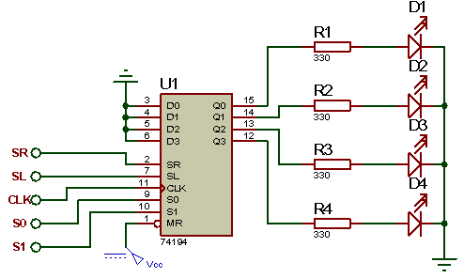
Figure 7.11

 | SR | SL | S0 | S1 | CLK | LED1 | LED2 | LED3 | LED4
1 | 0 | 0 | 1 | 1 | ↑
2 | 1 | 0 | 1 | 0 | ↑
3 | 1 | 0 | 1 | 0 | ↑
4 | 1 | 0 | 1 | 0 | ↑
5 | 1 | 0 | 1 | 0 | ↑
6 | 0 | 0 | 1 | 1 | ↑
7 | 0 | 1 | 0 | 1 | ↑
8 | 0 | 1 | 0 | 1 | ↑
9 | 0 | 1 | 0 | 1 | ↑
10 | 0 | 1 | 0 | 1 | ↑
11 | 0 | 0 | 0 | 1 | ↑
12 | 0 | 1 | 0 | 1 | ↑
13 | 0 | 1 | 0 | 1 | ↑
14 | 0 | 1 | 0 | 1 | ↑
15 | 0 | 1 | 0 | 0 | ↑
16 | 1 | 0 | 0 | 0 | ↑
17 | 1 | 1 | 1 | 1 | ↑
18 | 1 | 0 | 1 | 0 | ↑
19 | 0 | 0 | 1 | 0 | ↑
20 | 0 | 0 | 1 | 0 | ↑
Table 7.11

EXPERIMENT 7.12: SEVEN-SEGMENT-DISPLAY (COMMON CATHODE)
Realize the following circuit shown in figure 7.12 on a breadboard. Connecting pins 3 and 8 to GND and Va, Vb, Vc, Vd, Ve, Vf and Vg inputs to either GND or VCC based on the table 7.12, fill in the blanks.
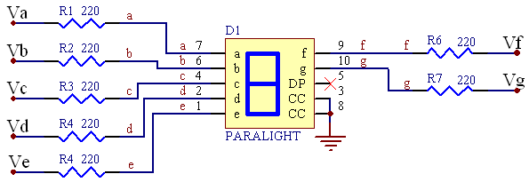
Figure 7.12

 | Va | Vb | Vc | Vd | Ve | Vf | Vg | Display
1 | 5V | 5V | 5V | 5V | 5V | 5V | 0V
2 | 0V | 5V | 5V | 0V | 0V | 0V | 0V
3 | 5V | 5V | 0V | 5V | 5V | 0V | 5V
4 | 5V | 5V | 5V | 5V | 0V | 0V | 5V
5 | 0V | 5V | 5V | 0V | 0V | 5V | 5V
6 | 5V | 0V | 5V | 5V | 0V | 5V | 5V
7 | 5V | 0V | 5V | 5V | 5V | 5V | 5V
8 | 5V | 5V | 5V | 0V | 0V | 0V | 0V
9 | 5V | 5V | 5V | 5V | 5V | 5V | 5V
10 | 5V | 5V | 5V | 5V | 0V | 5V | 5V
11 | 5V | 5V | 5V | 0V | 5V | 5V | 5V
12 | 0V | 0V | 5V | 5V | 5V | 5V | 5V
13 | 5V | 0V | 0V | 5V | 5V | 5V | 0V
14 | 0V | 5V | 5V | 5V | 5V | 0V | 5V
15 | 5V | 0V | 0V | 5V | 5V | 5V | 5V
16 | 5V | 0V | 0V | 0V | 5V | 5V | 5V
Table 7.12

EXPERIMENT 7.13: SEVEN-SEGMENT-DISPLAY (COMMON ANODE)
Take a common anode seven-segment-display and place it to the breadboard. Connect pins 3 and 8 to VCC and all other pins to GND. What is seen on the screen? By switching Va, Vb, Vc, Vd, Ve, Vf and Vg inputs to either GND or VCC obtain a number on the display according to the table 7.13. Fill in the blanks.
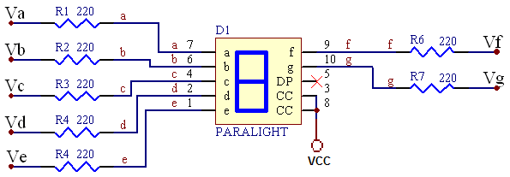
Figure 7.13

Display | Va | Vb | Vc | Vd | Ve | Vf | Vg
0
1
2
3
4
5
6
7
8
9
Table 7.13

TEST QUESTIONS

1. The transfer of new information into register is called _____ of register.
A. triggering B. Loading C. Set D. Reset E. none of above mentioned

2. Loading of register is done in parallel if

A. the bits of the register are loaded simultaneously

B. all the bits of the register are loaded simultaneously

C. all the bits of the register are loaded simultaneously with a clock pulse

D. all the bits of the register are loaded simultaneously with a single clock pulse

E. the bits of the register are loaded simultaneously with a single clock pulse

3. How many control signals has bidirectional shift register with parallel load got?
A. 2 B. 3 C.4 D.5 E.6

4. The content of a 4-bit shift register is initially 1101. The register is shifted 6 times to the right, with the serial input being 101101. What is the content of the register after the first shift?
A. 0101 B. 1100 C. 1110 D. 1101 E. 1010

5. What types of operation bidirectional shift register with parallel load has?
A. shift right, parallel load B. shift left, parallel load
C. shift right, shift left, parallel load D. Complement, no change
E. shift right, shift left, parallel load, no change

6. Feedback shift register is such type of register, when
A. each flip-flop transfers its content to the next flip-flop
B. each flip-flop transfers its content to the next flip-flop, when a clock pulse occurs
C. each flip-flop transfers its content to the next flip-flop, when a clock pulse occurs, but the next state of the first flip-flop(for MSD) is some function of the present state of other flip-flops
D. each flip-flop transfers its content to the next flip-flop, when a clock pulse occurs, but the next state of the first flip-flop(for LSD) is some function of the present state of other flip-flops
E. each flip-flop transfers its content to the next flip-flop, when a clock pulse occurs, but the next state of the last flip-flop(for LSD) is some function of the present state of other flip-flops

7. If Johnson counter has got 3 flip-flops, we can have sequence of _____ timing signals.
A. 3 B. 4 C. 5 D. 6 E.9

8. For what purpose is buffer used?
A. to reduce loading of the device to which the buffer is connected
B. to improve characteristics of the circuit C. to decrease propagation delay
D. to increase propagation delay E. all aforementioned answers are wrong

9. A flip-flop has a 10-ns delay from the time its CP input goes from 1 to 0 to the time the output is complemented. What is the maximum frequency the counter can operate at reliably?
A. 5 MHz B. 6.25 MHz C. 8.33 MHz D. 10 MHz E. 12.5 MHz

count=1
clear=1
CP
0
0
1
0
load
A
A
A
A
4
3
2
1
10. The circuit below is a mod-_____ counter.
A. 1 B. 2 C. 3 D. 4 E. 5

